

University of Greenwich ID Number: 001279354

FPT Student ID Number: GBS190594

Module Code: BUSI-1714-M02-2022-23

Module Assessment Title: REPORT

Lecturer Name: Tran Xuan Linh

Submission Date: August 15, 2023.

**CONTENTS**

**1. Introduction: 3**

**2. Business idea: 3**

**3. Source of idea: 6**

**4. Value Proposition: 7**

**a. VRIO: 7**

**b. Value Proposition: 8**

**5. Our Mission: 8**

**6. Our Vision: 8**

**7. Primary Research: 8**

**a. Survey: 8**

**b. Interviews: 9**

**Background: 9**

**8. Secondary research: 10**

**b. Market Size: 11**

**9. Micro-environment analysis - Porter’s five sources 11**

**10. Macro-environment analysis (PESTEL) 13**

**11. SWOT Analysis: 16**

**12. Customer Requirements: 17**

**13. Business Strategy – The Ansoff Growth Matrix: 18**

**14. Business Objectives - Strategy house model: 19**

**15. MARKETING: 20**

**a. Paid media: 20**

**b. Own media: 20**

**c. Earned media: 20**

**a. TAM – SAM – SOM: 21**

**b. Cashflow Forecast Template: 22**

**17. Suppliers & Partners: 23**

**a. Suppliers: 23**

**b. Partners: 23**

**18. Human Resource Management (HRM): 24**

**19. Conclusion & Reflection: 25**

**References 26**

**Appendix: 31**

# Introduction:

This report introduces Chang Vegetarian Restaurant's plant-based meat production and sales project. With a focus on sustainability, health, and taste, the company's mission is to provide a wide range of plant-based meat products that are effective in all aspects. Through extensive research and development, Chang Vegetarian Restaurant brand has created innovative formulas that replicate traditional flavour texture, flavor, and nutritional composition while using plant-based ingredients. Chang Vegetarian Restaurant's commitment to ethical and eco-friendly practices extends to sourcing ingredients from responsible suppliers and implementing environmentally conscious production practices. The author envisions a future where plant-based meat becomes the preferred choice of sober consumers looking for a healthier and more sustainable lifestyle. By partnering with local farmers, distributors, and retailers, the business aims to make its plant-based meat products available to a broader audience. Join the author as Chang Vegetarian Restaurant revolutionizes the meat industry and paves the way for a greener, more compassionate future.

# Business idea:

Chang Vegetarian Restaurant is a restaurant project specializing in research, production and sales of plant-based meat products that is about to be launched in Vietnam. Unlike traditional vegetarian meat products on the market, plant-based meat is made with amino acids, structural units of protein extracted entirely from plants, with structure, sensory, color, and taste 90% like animal meat with similar nutritional value. Plant-based meats will be produced and packaged in fresh and frozen form for retail to vegetarian customers and sold in bulk to restaurant distribution channels such as large and small vegetarian restaurants and small businesses. The source of production materials is always guaranteed of quality, they are mainly imported from a number of domestic farms and imported from abroad to be able to produce and sell to the market at a cheaper price than other brands. At the same time, this plant-based meat product is also processed by chefs into attractive dishes for business in the form of restaurants in the model of a cloud kitchen and packaged product lines developed in the future.

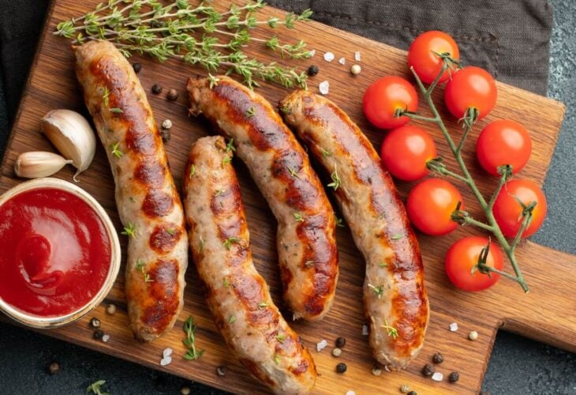

**Figure 2a: Plant-based sausage**

**Source: Webber, 2021.**

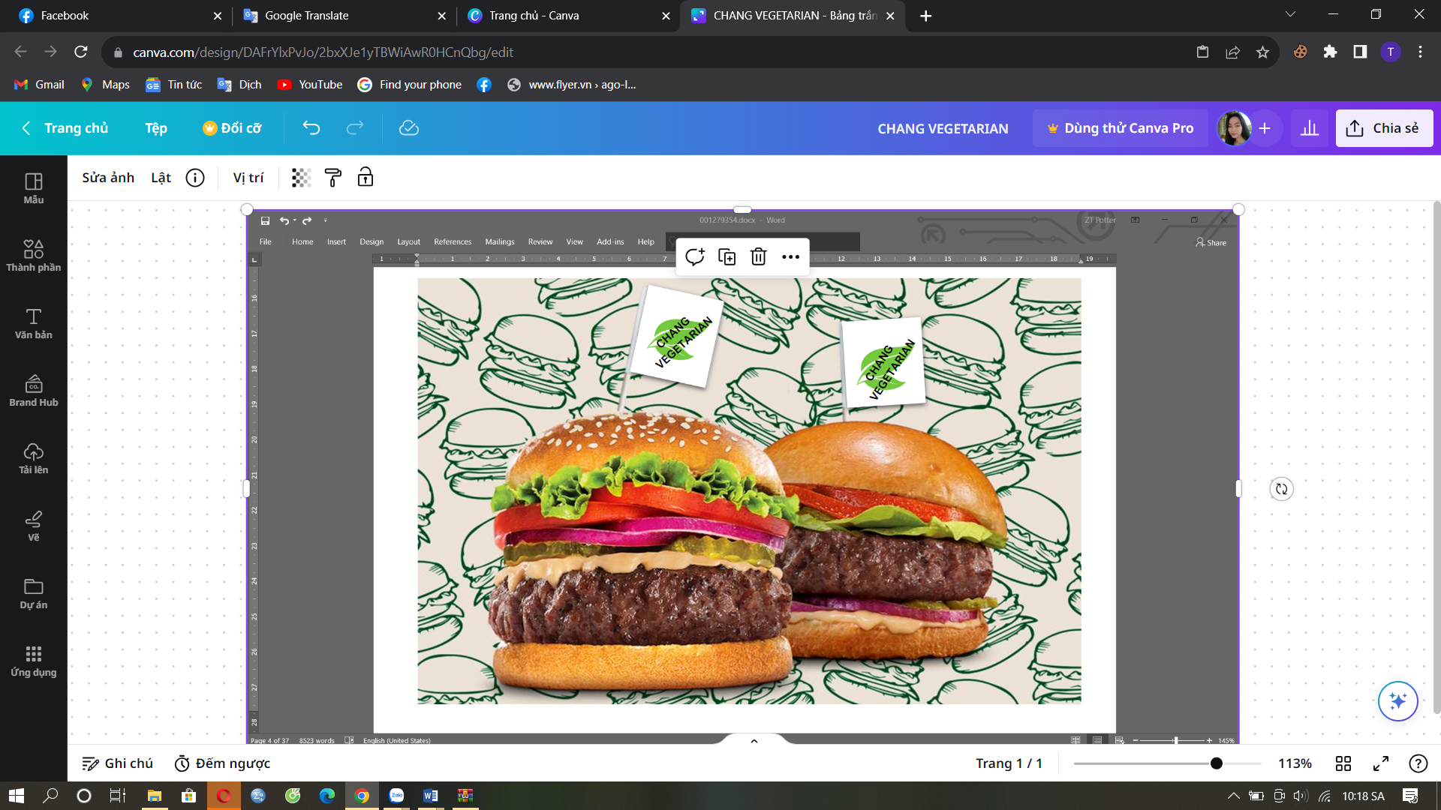

**Figure 2b: Plant-Based Burger Patties**

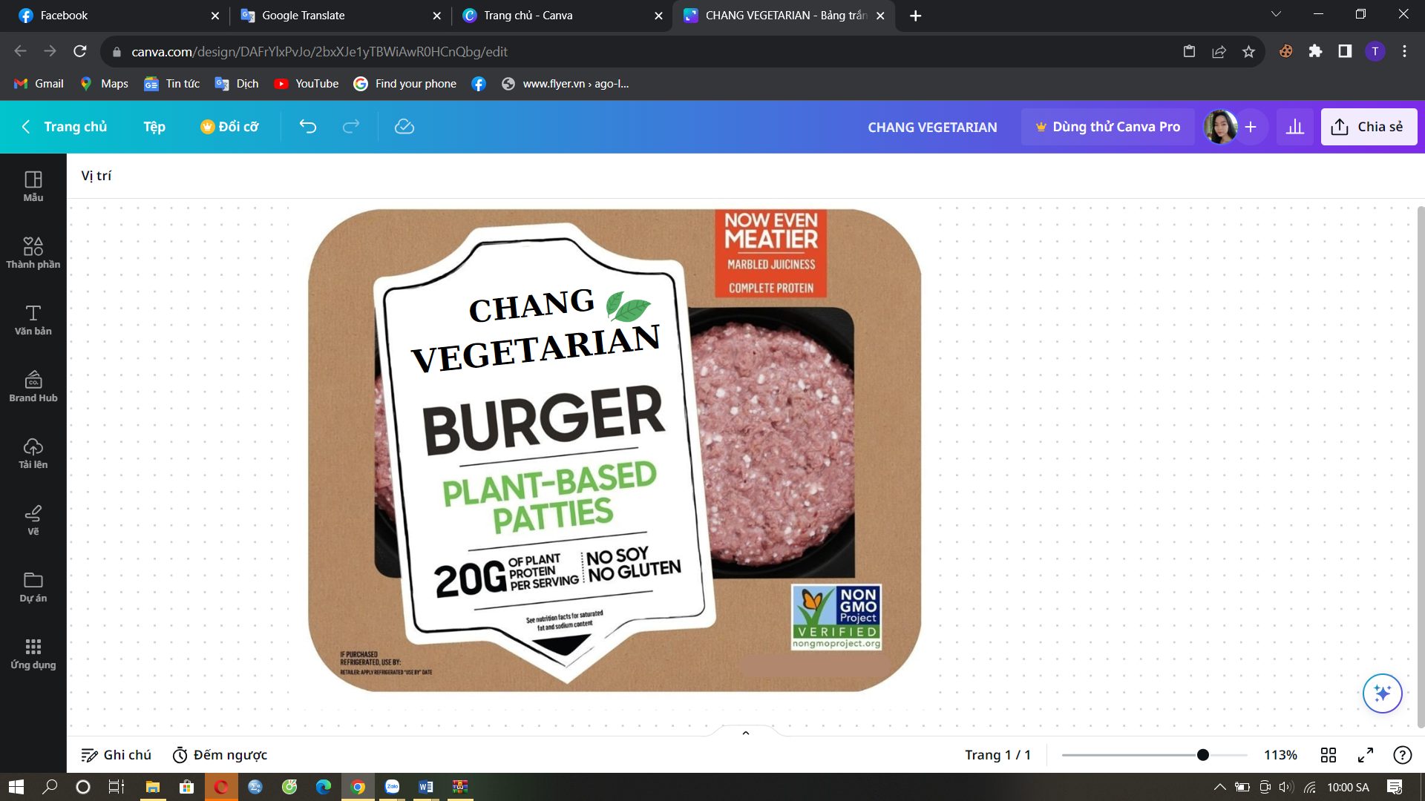

**Figure 2c: Plant-based meat**

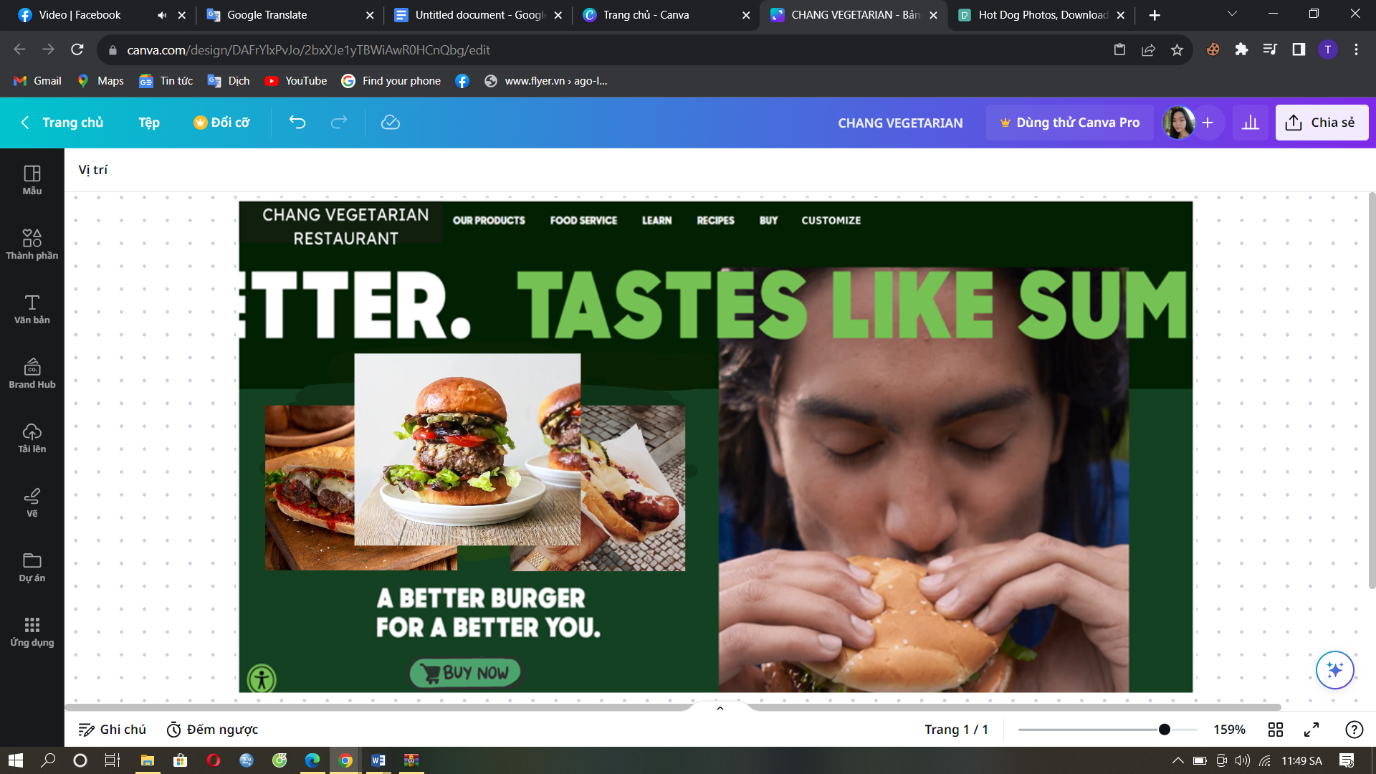

**Figure 2d: Website Demo Board**

Chang Vegetarian Restaurant will provide channels to sell “plant meat products” on platforms like Facebook, Instagram, and other fast food delivery apps. Websites will be designed with a user-friendly interface filled with essential information including recipes so that people can enjoy “vegetable meat” in the best way. The restaurant will provide a tab that shows the total calories of each ingredient currently in stock and suggests the best way to mix so that customers can also enjoy theirfavouritee dishes with more appropriate calories with each individual. The service is intended to cater to certain customers who may have allergies, have a job that requires more calories or don't like certain ingredients on the menu. The menu will be researched and created according to the season or holidays of the year, with periodic menu packages and multi-course set cooking for parties. Customers must book at least 1 day in advance for the restaurant to bring the best quality of service to customers.

# Source of idea:

At the beginning of 2021, while everyone was busy preparing everything to celebrate the Vietnamese traditional Lunar New Year, the author's dear grandfather passed away due to a serious illness by unhealthy eating habits. After the funeral, the whole family had to be vegetarian according to the religious regulations the of Cao Dai religion. The author began to care about the health of himself and his family more with the requirements of clean ingredients and clear origin. The author's vegetarian diet started quite difficult, so the author joined vegetarian groups on to learn how to eat more scientifically and cook delicious and nutritious vegetarian dishes. They helped the author open a new door in life, made the author love vegetarianism, and maintain it to this day.

The author then conducted further research into why so many people turn to vegetarianism and its benefits. According to many studies, vegan dishes are rich in nutrients such as animal protein and promote overall health through the most specific benefit of reducing the risk of colorectal, breast, and prostate cancer (Waller, 2022). A 2016 FAO report indicates that 18% of global greenhouse gas emissions are attributable to livestock (Ghosh et al., 2020). When it comes to sustainable business benefits, vegan products can reduce food carbon emissions by 29-70% and reduce global mortality by 6-10% (Goyal et al., 2020). Based on these numbers, the author feels proud of herself because just by changing her eating and living habits, she can contribute to the fight against animal killing as well as climate change global.

On the other hand, the author found that the range of vegetarian meat and prepared vegetarian dishes on the market today have many fake products (mixed meat, animal organs and fish) or poor quality, quite high prices and not many choices. The seriousness of counterfeit products does not stop at just insulting religion, with the amount of chemicals in it that can negatively affect the health of consumers. The author wants to build a vegetarian paradise full of protein and unique experiences for vegetarians, especially vegetarians for health and religion.

# Value Proposition:

## **VRIO**:

|  |  |  |  |  |  |
| --- | --- | --- | --- | --- | --- |
| VRIO Analysis | | | | | |
| Resources and Capabilities | **VALUABLE** | **RARE** | **INIMITABLE** | **ORGANISED** | **Competitive Implications** |
| Creative formula | **YES** | **YES** | **YES** | **YES** | **Sustainable Competitive Advantage** |
| Product price | **YES** | **YES** | **NO** | **YES** | **Unused Competitive Advantage** |
| Technology and social networks | **YES** | **NO** | **NO** | **YES** | **Temporary Competitive Advantage** |
| Customer perception | **YES** | **NO** | **NO** | **YES** | **Temporary Competitive Advantage** |
| Popularity in the market | **YES** | **NO** | **NO** | **NO** | **Competitive Parity** |
| Partnerships network | **YES** | **NO** | **NO** | **NO** | **Competitive Parity** |
| Production Capacity | **YES** | **NO** | **NO** | **YES** | **Temporary Competitive Advantage** |
| Service quality | **YES** | **YES** | **NO** | **YES** | **Unused Competitive Advantage** |

Resources that can bring a sustainable competitive advantage to Chang Vegetarian Restaurant's business include innovative plant-based meat recipes that create diverse product lines (fresh meat, sausages, burger fillings, meatballs) and the exceptional service that the business will bring. Technology and social media help food industry businesses with social media marketing and market orientation, contributing to future competitive advantage (Lie et al., 2022). Besides, another factor that creates an advantage for Chang Vegetarian Restaurant is the cost of plant-based meat; compared to the quality of products that the business provides, the price will be lower than the general level of other brands' products. On the other hand, as a startup, Chang Vegetarian Restaurant's reputation in the industry and stakeholder network will not be high. At the same time, when the demand for plant-based meat increases rapidly, and the number of orders is large, businesses will be able to face the challenge of producing products in large quantities because the production scale is small.

## Value:

Chang Vegetarian Restaurant offers high-quality, reasonably priced plant-based meats and a varied menu with a variety of healthy creative recipes. Besides, the business is also committed to bringing the best service experience from the store system to online ordering.

# Our Mission:

Bringing people a great experience through green, clean, and great-tasting products.

# Our Vision:

To become the leading local and international vegan restaurant brand that offers affordable and nutritious vegan products.

# Primary Research:

## Survey:

The author has conducted a survey to collect data from consumers, who are mainly vegetarians. The survey was conducted online and collected data from 219 members from various vegan groups on Facebook, from which Quantitative Research/Analysis. According to market survey data obtained, the majority of vegetarian customers usually focus on the 18 - 40 years old segment, accounting for 81% of the total 219 survey participants. Occupational survey data also shows that 49% are office workers, 18% are students, 17% are currently housewives, and the remaining 13% are physically demanding workers much healthy. For the question of frequency of going to restaurants, 53% of people sometimes and 22% often choose to go to restaurants to be vegetarian. In addition, the majority of vegetarians will follow the Lacto-Ovo Vegetarians diet (still using eggs and milk) with 36.4% and 29.1% of vegans (100% plant-based). The last metric of interest in the market survey is the income of 47.3% of users ranging from 5 to 15 million/month, and 36.4% of people with revenue ranging from 15 to 30 million/month.

Next is a survey to evaluate the feasibility of the product from 100 people who have used the plant-based meat product of Chang Vegetarian Restaurant. Statistics from the survey show that about 4.1% of people feel loved and satisfied with what the business's plant-based meat brings. 3.8% of testers recognized the product's ability to provide the same amount of nutrients as real animal meat and felt they were unique. In addition, 3.9% of people who tried the product also felt confident in the product. Finally, about 3.8% of people thought that the quality and price of the plant-based meat products of Chang Chang Vegetarian Restaurant are now reasonable compared to the consumer spending.

## Interviews:

## Background:

According to data obtained from 12 interviewees, they are in the age group of 25-40 years old and 60% are office workers. In which, 85% of participants follow a vegan diet, 15% are vegetarian on special occasions and they are vegetarian mainly for their health. About 2 participants added that their parents, who are also vegetarians, and some of their friends also have the same vegetarian options. They don't have much trouble going vegan, as they ensure proper nutrition and have a variety of vegetarian food options available, including plant-based meats. 70% of respondents felt like vegetarianism at home and occasionally at vegetarian restaurants. All interviewees appreciated plant-based meats for their taste and texture without harming animals or the environment. Overall, vegetarian lifestyles are supported by their loved ones and aligned with their personal values.

**Interest:**

Interviewees expressed their motivation to purchase and use plant-based meat products, highlighting factors such as convenience, taste, and ethical considerations. Overall, they are satisfied with the current price, finding it reasonable and affordable. The texture, feel, color and taste of plant-based meat met their expectations, closely resembling animal-based meat. Plant-based meat is used in a variety of dishes and combined with different sauces, demonstrating its versatility. There is an optimistic outlook on the potential of plant-based meat to replace traditional meat and vegan meats in the future, as more individuals become aware of its benefits. Overall, the feedback highlights the positive attributes and growth potential of plant-based meat products on the market.

**Suggestion:**

The interview indicated that while plant-based meat products are already close to animal meat in taste and texture, it should still be improved to offer more variations in flavor and texture. Current rates are considered reasonable, but a slight reduction could attract a larger customer base. Participants expressed interest in viewing new or improved plant-based meat products for different cuisines and occasions, such as sushi, barbecue, banh tet, and festive dishes. The communication and marketing methods used by the company are considered reasonable and effective, using a variety of channels and endorsements to inform and build trust among potential customers. Overall, the feedback highlights the potential for further product development and customer outreach.

# Secondary research:

* 1. **Market Share:**

**Source: Statista, 2023.**

In terms of plant-based meat market share, China is considered the most attractive vegan food market, accounting for 68% of Asia with total sales in 2023 of US$2.96 billion (Statista, 2023). In second place is Japan's market share, which accounts for 7.6% of the total market share in Asia with revenue reaching US$0.33 billion by 2023 (Statista, 2023). Indonesia accounts for 6.4% with a market turnover of US$275.80 million in 2023 (Statista, 2023). South Korea holds about 3% market share in Asia with sales of US$128.2 million in 2023 and Vietnam has a 1% share in Asia with total sales of US$43.41 million in 2023 (Statista, 2023). Overall, with 14% of the retail market share, Vietnam still has many opportunities to increase its market share in the future.

## Market Size:

**Source: Statista, 2023.**

Based on the data in the table above, the country of consumption and business with the highest revenue is the country of billions of people – China with US$10166.5 million and a CAGR from 2023 to 2028 of 27.99% (Statista, 2023). This is followed by Japan, Indonesia, South Korea and Vietnam with CAGRs from 2023 to 2028 of 7.94%, 7.84%, 14.52% and 13.85%, respectively (Statista, 2023). It can be seen that the size of the plant-based meat market has great potential for development for producers in Vietnam (Statista, 2023). This is clearly demonstrated by Vietnam's CAGR increasing by nearly 14% per year even though we are only a small market new to the industry compared to major powers such as China and Japan (Statista, 2023).

## Trend:

The meat substitution trend in Asia has been gaining more and more attention and popularity in recent years with people looking for alternatives to animal products for a variety of reasons. The market value of meat substitutes in Vietnam with sales of $34 million by 2023 and an expected annual growth rate of 10.4% from 2023 to 2028 (Statista, 2023). Many consumers are becoming more concerned about the health, environmental and ethical factors associated with traditional meat production. They tend to turn to meat alternatives as an alternative to protect their health and reduce greenhouse gas emissions. The meat substitute industry has seen a spike in innovation and investment in recent years. Some of the leading companies in this space are Impossible Foods and Beyond Meat, which have received millions of dollars in funding from investors such as Bill Gates, Google Ventures and Reddit co-founder Alexis Ohanian.

# Micro-environment analysis - Porter’s five sources

An analytical model called Porter's Five Forces is used to help establish an industry's structure and to assist businesses in developing their competitive strategies (Hall, 2023).

|  |  |
| --- | --- |
| Competition in the industry (High) | Vmeat brand is part of Cay De Vegetarian Food Production and Trading Co., Ltd. has launched and is currently trading the best plant-based meat products with the investment of Shark Louis and Shark Lien in the Shark program. Tank Vietnam (Bao Han, 2021).  Au Lac Vegetarian Food Production Co., Ltd is also equipped with machinery and production lines imported from Germany and European countries (Au Lac, n.d.). Au Lac has produced more than thousands of different products for domestic sale and international export such as in Germany, Canada, the USA, and Australia (Au Lac, n.d.) |
| Potential of new entrants into the industry (Medium) | Vegetarian restaurants appear in big cities such as Hanoi, Ho Chi Minh City, and Hai Phong, creating competition in the industry that will reach a high level in a short time (TRONG et al., 2021).  As of 2022, there are 1,200 vegetarian restaurants in Ho Chi Minh City and 200 vegetarian restaurants in Hanoi registered on Foody (Hoang, 2022).  Many spontaneous individuals and businesses take advantage of Facebook's popularity and utility to sell various vegetarian products (Thu et al., 2019). |
| Power of suppliers  (Medium) | Suppliers of materials that have a monopoly or control over key materials will have the power to change prices or impose conditions on manufacturers (Niu et al., 2022).  Suppliers have the power to set conditions and requirements in material supply contracts in certain contexts (Skowronski et al., 2022).  Suppliers have the power to provide quality and reliable raw materials to ensure no interruptions or shortages in the production process (Skowronski et al., 2022). |
| Power of customers  (High) | Customers have the right to choose from a wide range of plant-based meat products on the market (Sridhar et al., 2022).  Customer feedback can help a business improve and grow, but it can also kill a brand (Rasouli et al., 2022).  The increase in demand and customer support can influence market trends and the development direction of the plant-based meat industry (Tyndall et al., 2022).  Customers have a right to high demands on quality and expect that manufacturers provide safe and highly nutritious plant-based meat products (Szenderák et al., 2022). |
| Threats of substitute products (Low) | New vegan products in Vietnam are now quite diverse from modern to traditional and in line with the tastes of consumers who tend to prioritize convenience products and green foods such as instant noodles, vermicelli, and noodles crab, soup cake, brown rice vermicelli (DONG et al., 2021).  Vietnam is a country that consumes a lot of farmed and wild animal meat, and animal-based dishes can replace and compete strongly with plant-based meat (Duy, 2022). |

# Macro-environment analysis (PESTEL)

Maliki et al., (2012) suggest that PESTLE is a tool that can identify factors that can affect an organization and then find ways to correct these factors. Later, Hall (2023) also agrees when giving another definition, adding that PESTLE is an analytical tool that businesses can use to determine whether external influences affect their operations. their own and increase the level of competition in their market.

# SWOT Analysis:

SWOT analysis is a framework used to assess a company's competitive position and to create strategic planning (Kenton, 2023). The SWOT analysis evaluates internal and external variables as well as present and anticipated future situations (Kenton, 2023).

In terms of ***strengths***, currently, there are few competitors offering plant-based meat products in the market such as Chang Vegetarian Restaurant, Vmeat, Vinamit, Bien Phuong Co., Ltd - Trading – Service. The company's plant-based meat products will be produced under an innovative and continuously innovative formula to create product diversification that positively impacts business performance in the food and beverage industry (Wegwu, n.d.). Currently, the price of plant-based meat in Vietnam fluctuates around US$ 12.62/kilogram, which is only about 1/5 the price of Beyond's products, about US$ 63.76/kg (UK, 2021). The business will also apply a number of technologies such as automatic dough mixers, meatball presses, food dryers, vacuum packaging machines. Because of the concern about each customer's calorie count, Chang Vegetarian Restaurant should there are more services mixing ingredients and many other services to best serve customers.

Talking about ***the weaknesses*** of the project, this is just a new startup in the industry, so at first the brand will be little known and almost no influence in the industry. As a result, businesses will have very few strategic partnerships to work with well-known companies to increase the restaurant's market reach, increase consumer awareness and provide opportunities for growth. product development. Investments in production equipment are also limited, so the initial amount of equipment will be small, leading to production challenges if the business receives many bulk orders in the future. Only the two most famous plant-based meat producers in Vietnam, Au Lac and Vinamit, have dominated the market, putting competitive pressure on new entrants such as Chang Vegetarian Restaurant. In the international framework, Beyond Meat and Impossible Foods have also invested in developing Asia, especially the billion-people market - China (Tan et al., 2020). In addition, the majority of Vietnamese people still prefer to consume animal meat, as evidenced by the average consumption of 23.5 kilograms of pork per person in 2022 (Tu, 2022).

***Opportunities*** are gradually expanding for the plant-based meat market as more and more established vegetarian restaurants have expanded the market to import plant-based meat in large quantities for restaurants (IN et al., 2021). More and more vegetarians spread the message and help the number of vegetarians increase rapidly globally on social networks (Cherry, 2015). At the same time, the Vietnamese government has always supported domestic enterprises to reach international levels by promoting international trade with 16 free trade agreements signed or under negotiation to facilitate the import of raw materials and export of plant-based meat in the future (Harris et al., 2022). Social media channels such as Facebook, Instagram, Youtube, and Tiktok are a fertile virtual market for plant-based meat businesses (Thu et al., 2019). Facebook alone in 2022 has more than 6 billion users of Facebook advertising in Vietnam (Statista, 2023).

***Threats*** of the production and trading of plant-based meat mentioned first is that the high consumption rate in Vietnam will cause consumer spending to decrease and they will choose other food products to save money instead of spending more on healthy meals (World Bank, 2022). The next risk comes from plastic, which is considered the most harmful material for consumer goods, with 65% of global consumers saying that plastic will pollute the oceans, especially marine life (Zhongming et al., 2020). Finally, the problem that international science also has a headache, climate change affects food production (vegetables), product quality, disease outbreaks, and has a direct impact on wage market prices real (Abbass et al., 2022).

# Customer Requirements:

Based on the quantitative and qualitative survey mentioned above along with micro and macro environment analysis, the report draws customer requirements as follows:

In terms of quality, plant-based meat products produced by Chang Vegetarian Restaurant will have ingredients made from 100% plants. The product will be thoroughly researched and tested so that when eating, customers will feel the softness, chewiness, taste, and nutrition more than 90% like it and can replace animal meat on the market. The source of production materials must have the origin and the expiry date posted. All products before launching into the market will be thoroughly tested and licensed for food safety and hygiene as well as business licenses from the government. At the same time, the plant-based meat of Chang Vegetarian Restaurant will contribute to solving consumer health and environmental problems such as no cholesterol, no antibiotics, and no hormones, saving 99% water, saving 93% land, 90% GHGE reduction, and 46% energy reduction.

In terms of design, plant-based meat products will be produced in the form of sausages, burger fillings, meatballs, and ground meat to meet the needs and preferences of each customer in each region. different geography. Plant-based meat will be packaged in trays or vacuum bags so that customers can reuse it if needed. The outer layer of the package will have information, a specially designed anti-counterfeiting stamp, an image of the product, and specific business information to ensure reliability for customers. Vegetable meat can be stored in the refrigerator or freezer like animal meat and has a longer shelf life due to the absence of bacteria from animals (Win, 2021).

The price offered for instant dishes combined with plant-based meat at the restaurant is US$2/dish and US$3 for a tray of plant-based meats. This is said to be the price most consumers can afford and is only 1/5 of the imported plant-based meat. Plant-based meat of Chang Vegetarian Restaurant also has a warranty if the product is defective or damaged within the shelf life provided by the business. Accordingly, the business will provide a return or refund mode for customers if the product has problems and defects due to the manufacturer. The enterprise also provides a QR code on the product packaging so that customers can access the website to receive the necessary advice and support and maintain the relationship between the customer and the business.

# Business Strategy – The Ansoff Growth Matrix:

The Ansoff Growth Matrix is a strategic planning and management tool that helps businesses manage marketing to plan strategies to expand this business in the future (Clarissia, 2020). Ansoff Matrix consists of four strategies: market penetration strategy, market development strategy, product development strategy, and diversification strategy (Clarissia, 2020).

|  |  |  |
| --- | --- | --- |
| **EXISTING PRODUCTS** | | **NEW PRODUCTS** |
| **EXISTING PRODUCTS** | ***Market Penetration Strategy:***  Chang Vegetarian Restaurant will invest heavily in marketing to expand its market share in the South and penetrate the Central and Northern markets. | ***Product Development Strategy:***  Launched more plant-based meat products such as seaweed-based fish meat, goat meat, and convenience products that can be cooked and frozen such as braised pork, stewed soups, meatballs, curries, and more. |
| **NEW PRODUCTS** | ***Market Development Strategy:***  Exports of plant-based meat products have been localized to countries such as China, Japan, South Korea and European countries. | ***Diversification Strategy:***  Partner with major brands to produce vegan fashion, vegan pet products, or vegan cosmetics to complement its core business. |

The strategy chosen in the Ansoff Growth Matrix for Chang Vegetarian Restaurant to develop is the product development strategy. Because the market is constantly changing and developing, and the needs of consumers are increasing, Chang Vegetarian Restaurant will always have a team of continuous product research and development. In addition to the available meats, the company will launch more plant-based meat products such as fish meat made from seaweed, goat meat. Especially convenient products that can be cooked. and frozen like braised pork, stewed soup, meatballs, curries. With this convenience, customers can keep their purchases for a long time by freezing and defrosting when used with pure taste of Vietnamese cuisine. These products belong to the potential processed food industry, accounting for more than 20% of the net revenue of the processing and manufacturing industry every year (GSO, 2021).

A good example is Vissan's processed food industry with revenue of VND 1211 billion in the first 6 months of 2021 and a higher gross profit margin than fresh meat (26% vs 15%) (Van, 2021). Specifically, Vissan sells processed foods with a profit of VND 321 billion and sells fresh meat for only VND 155 billion (Van, 2021). In fact, processed plant-based meat products will likely be easier to export to foreign countries in the future than raw meat. At the same time, this product line only needs to change one way of processing, Chang Vegetarian Restaurant's plant-based processed meat can also penetrate the Chinese market because of their preference for meatballs, braised meat.

# Business Objectives - Strategy house model:

Implement stringent quality control measures to ensure consistency and safety of plant-based meat products.Adhere to food safety regulations and standards to build consumer trust.

Incorporate sustainable sourcing of ingredients, such as using non-GMO crops and minimizing reliance on resource-intensive plants.

Establish a diversified product research and development team.

Engage with consumers through marketing campaigns, cooking demonstrations, and online content to promote plant-based meat products.

**Great people Quality product Convenient place**

**GOALS**

**FOUNDATION**

**INITIATIVES**

Scaling up production and distribution of plant-based meat in new markets.

To become the leading local and international vegan restaurant brand that offers affordable and nutritious vegan products.

**VISION**

**MISSION**

Educate consumers about the benefits of plant-based diets, including health, environmental, and ethical considerations.

Create a diverse range of plant-based meat products with various flavors, textures, and culinary applications.

Bringing people a great experience through green, clean, and great-tasting products.

The business has outlined three main goals including communicating the benefits of a plant-based diet, including health, environmental and ethical considerations to consumers. It also creates a wide variety of plant-based meat products with a variety of flavors, textures and culinary applications. The ultimate goal is to scale up production and distribution of plant-based meat in new markets. In order to achieve the above mentioned goals, Chang Vegetarian Restaurant will establish a diversified product research and development team. The business will focus on interacting with consumers through marketing campaigns, cooking demonstrations and online content to promote plant-based meat products. Plant-based meat products will be produced using sustainable ingredients, such as using non-GMO crops and minimizing reliance on resource-intensive crops. Chang Vegetarian Restaurant will implement strict quality control measures to ensure the uniformity and safety of plant-based meat products. Enterprises always comply with regulations and standards on food safety to create trust for consumers.

# MARKETING:

Chang Vegetarian Restaurant's Plant-based meat products will attract more middle-income customers. The number of target customers selected by the author to invest in advertising are women from 26 to 40 years old. Those who are vegetarian for religion, animal protection, and health care for themselves and their families are often women. According to data from the Food Safety Authority - Ministry of Health (VFA), more than 50% of the Vietnamese population is often the ones who directly choose to buy, process and preserve food for the family (VFA, 2023). They also take an active role in propaganda, education, and food safety inspection (VFA, 2023). Besides, more women will be vegetarian to preserve their beauty and lose weight than men.

The following marketing strategy will be divided into 3 main stages and applied to the Paid - Owned - Earned model:

* Phase 1 is the period before and 1 month after the restaurant opens.
* Phase 2 is the time when the restaurant operates from the 2nd month onwards.
* Phase 3 is after the restaurant has come into stable operation from the 3rd month to 1 year of operation.

## Paid media:

In phase 1, the restaurant will focus on spending money on social media marketing through building attractive restaurant promotional videos on Facebook and Instagram. Specifically, introducing the restaurant space, services, delicious vegetarian dishes, and the best seller is plant-based meat to attract customers and increase page followers. The survey shows that 46% of participants like promotions, discounts and 16% like to receive gifts, so restaurants can apply discounts on opening day to attract customers.

Phase 2, the restaurant will invest in the cost of running ads through Tiktok, hire a vegetarian Tiktoker to promote Chang Vegan Restaurant, and run a discount program (go 5 to pay 4) to attract new customers. Invest in Google Ads and target key search keywords to show your restaurant's brand and reputation first when someone searches for related keywords.

After 1 year of operation, the restaurant will continue to run digital ads to reach a larger number of customers. The restaurant will send information via email to member customers about the restaurant's new promotions, products, and services.

## Owned media:

In phase 1, the restaurant will build a social networking site to promote products and receive orders. Chang Vegetarian Restaurant will generate QR codes to simplify the ordering process with online menus and payment for customers. Businesses will promote online ordering and delivery services through restaurant-owned media channels to create awareness and drive sales. This will make it easier for customers to access the most up-to-date prices and services, ingredient recommendations, and complete nutritional information. During phases 2 and 3, the restaurant's media channels will regularly post food or restaurant reviews from customer feedback. Accompanied by a video message about the product's benefits to customers and society, as well as propaganda about environmental sustainability. The restaurant will also regularly update the latest information on products, services, new events, promotions or recruitment news via the Website, Facebook homepage, Instagram and order channels.

## Earned media:

Throughout Phase 1 to Phase 3, the restaurant will continuously encourage and collect many customer experience reviews about the restaurant on Facebook, Instagram, ordering applications, and reviews on Google to improve its reputation and attract new customers. Restaurants can also host food or experience photo contests with user-generated content offers to encourage new and returning customers to create unique "#" hashtags that boost brand popularity. At the same time, the restaurant will also regularly monitor and respond to reviews to show participation and commitment to change and develop more positively to improve customer satisfaction.

In phase 3, to maintain its hotness, the restaurant will invest in booking about 10 Tiktokers and YouTubers to review the restaurant or sponsor the restaurant's products to some Tiktokers according to healthy content or vegan to make promotional videos for the restaurant.

Particularly with the restaurant's Tiktok and Youtube channels, we can create content about recipes or popular veganism, health, and free online cooking classes. To increase brand popularity as well as attract more customers, easily get more ads for other vegan products. Restaurants should also create membership cards for guests to maintain a loyal customer base as well as promote the brand through those cards because customers can bring the card to show off to their friends and relatives. Restaurants may also be involved in supporting local organizations or sponsoring events. This engagement can lead to media coverage and building a positive brand image. Chang Vegetarian Restaurant's **advertising slogan is "Every bite you take counts."** The meaning behind that is that the vegetarian dishes provided by Chang Vegan Restaurant are of high quality, and reasonable prices to help diners eat well, protect health and save costs.

1. **FINANCE:**

## TAM – SAM – SOM:

|  |  |
| --- | --- |
| **TAM** | The Vietnamese market has 9,000,000 vegetarians, accounting for about 10% of the country's population (World Population, 2023). On average, each transaction will be about US$2 and each customer trades twice a month. Thus, TAM according to the size of the Vietnamese market is US$432,000,000. |
|  | |
| **SAM** | During this period, Chang Vegetarian Restaurant has the ability to approach the Ho Chi Minh City market with an expected 500,000 customers through marketing, an average transaction of about 500,000 VND and twice a month (2 full moon days/month) per client. Thus, SAM for the Ho Chi Minh City market is US$24,000,000, accounting for about 5.6% of the total size. |
|  | |
| **SOM** | With an average monthly plant-based meat sales of Chang Vegetarian Restaurant estimated at US$6,000 and an estimated SAM scale of US$24,000,000. The enterprise's SOM is calculated as 0.3% market share. |

## Cashflow Forecast Template:

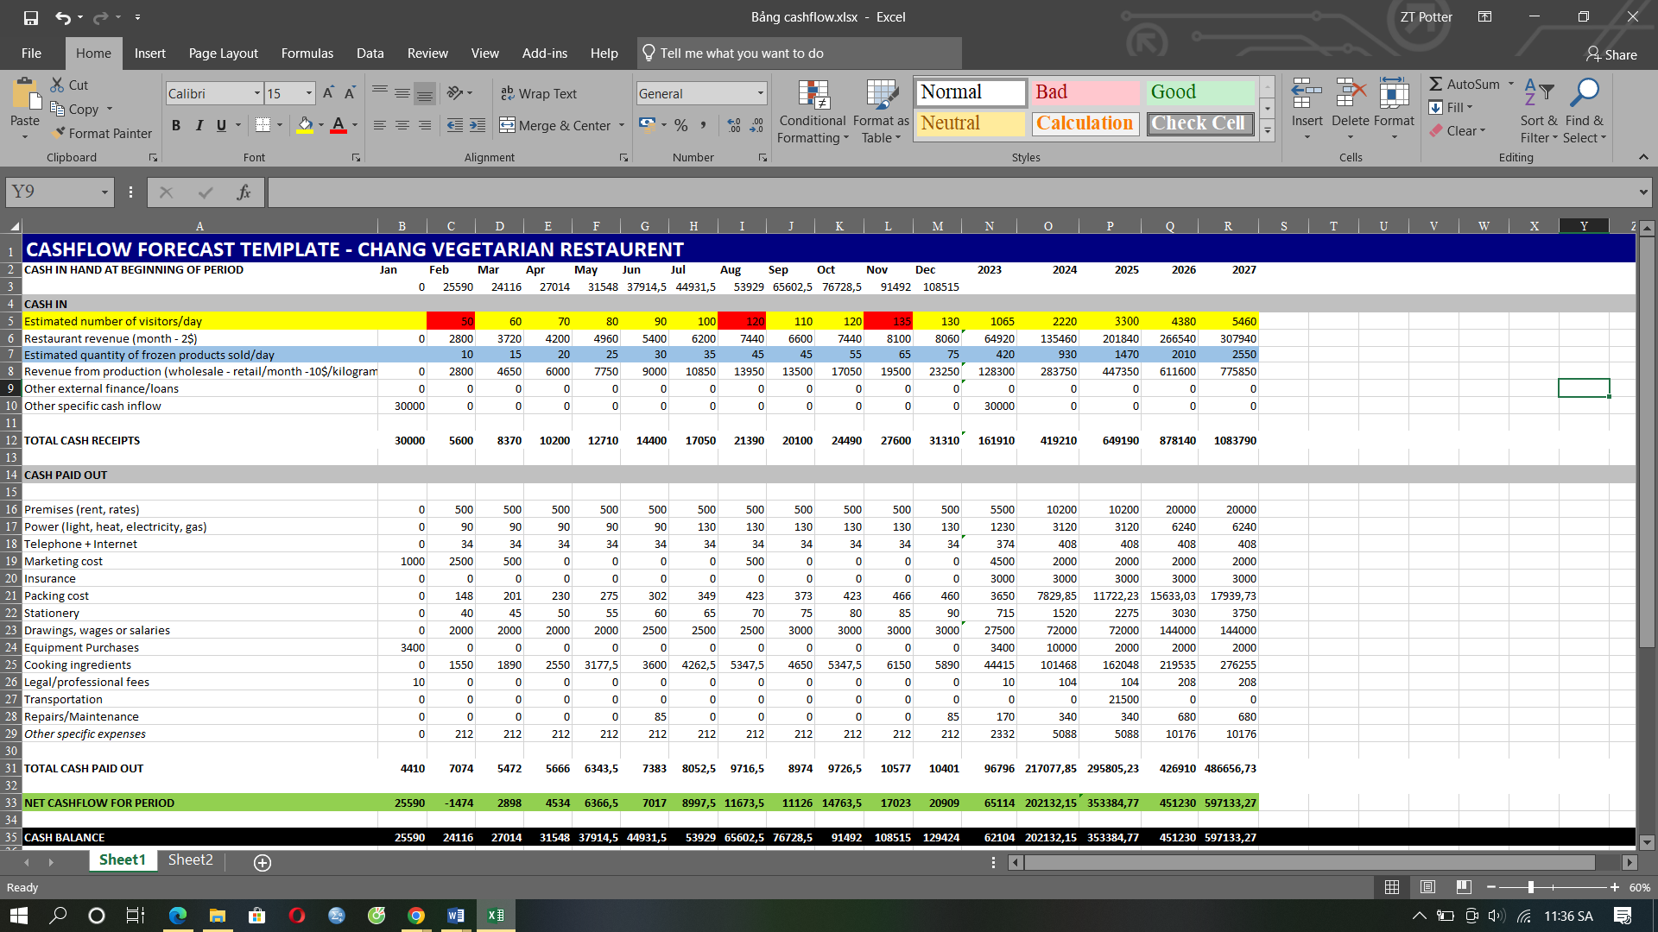

**Source: Author**

A summary of the cash flow table, Chang Chay Restaurant has a total investment of $30,000 and will invest about $4,500 in buying production equipment and running marketing first. The remaining cost will be used to rent the location to build the production facility, pay other expenses and also be the working capital when operating in Ho Chi Minh City. In order to avoid the risk of interest rate fluctuations, unnecessary expenses and other complicated legal procedures, the enterprise will not accept any bank mortgage loans in the Vietnamese market. Mortgage interest rates in Vietnam were most recently still high compared to other countries despite previous announcements of reductions to boost business, ranging from 6.4% to 8.5% or more (VPBank, 2023).

The leased premises for the establishment of offices, production and business facilities are initially expected to rent about 64m2 according to legal procedures and the total actual usable area is up to 160m2 with 2 floors. The author has signed a long-term lease on this space of a relative, so the rental cost will be discounted and lower than the real price in the real estate market. Initial production equipment totaled around $3,400 including freezers, refrigerators, stoves, cooking essentials, and other equipment (See the specifics below the appendix section). Vehicles for transporting raw materials and distributing products will be added after 2 years of operation worth USD 21000 instead of renting service cars. Due to the low initial investment capital, most of the tasks such as human resource management, marketing and strategy will be undertaken by the author to save costs.

The business's main revenue comes from producing and trading meat of plant origin. There are 3 peak months of the year which are February, August and October according to the culture of many Buddhists. Total sales of frozen plant-based meat in 2023 are 420 kg with sales of US$128,300 and ready-to-eat products are expected to sell at 1065 servings with US$64,920 in revenue. After deducting the projected total cost in 2023 (tax included) of $96,796, the restaurant's profit after the first year of business is $65,114. Other additional costs will cost about US$5088/year, averaging US$212/month but the author estimates it will cost more. It is expected that the output of plant-based meat in the following years will increase sharply thanks to marketing investment and the inherent reputation of the business that has been built after 1 year. Expected profit in 2024 is 217077 USD, in 2025 is expected to reach 295085 USD, and in 2026 is expected to reach 426910 USD. This number is roughly the same as the market % calculated in the TAM, SAM and SOM sections above.

Based on the figures provided in the cashflow table, the business will break even in March 2023, which is the 2nd month after trading. Cost of each product accounts for 50% and the profit is about 50%. The cost price is calculated from the price of preliminary materials when the author buys a small quantity, if buying raw materials in large quantities, the supplier will reduce the price so that the cost price can be reduced according to the price of the raw materials.

# Suppliers & Partners:

## Suppliers:

*Raw material suppliers:* organic farms, local markets, and flour production companies will deliver the freshest variety of vegetables, mushrooms, fruits, pulses, and seeds to the production facility. In the beginning, there will be staff from the production management department to check the quality of raw materials and control the punctuality of delivery and receipt. After that, through online ordering and receiving goods by loading, production management staff will periodically check the quality of crops and products from the farm.

*Sustainable packaging suppliers:* Choose a supplier that offers sustainable and eco-friendly packaging options. Look for compostable takeout containers, biodegradable utensils, and recyclable or reusable packaging materials to align with your restaurant's commitment to sustainability.

*Specialty Ingredient Suppliers:* Identifying suppliers that offer unique vegetarian and vegan ingredients, such as superfoods, specialty grains, fermented products, or exotic spices helps the chefs of Chang Vegetarian Restaurant creates creative and interesting dishes.

*Other vegetarian food suppliers:* A number of small businesses that offer vegetarian snacks such as snacks, desserts, handmade vegan cheeses, artisan bread, herbal teas, and other assorted foods. Customers can buy goods at the facility or order through menus on websites and apps.

*Equipment supplier:* As the production scale will expand to meet the needs of the market, plant-based meat production equipment will be supplemented, warranted, and periodically inspected such as stoves, ovens, mixers, presses.

## Partners:

*Organic Food Stores*: Partner with stores that share your commitment to natural products and distribute them.

*Nutritionists:* Form partnerships to provide expert advice on production, menu setup and customer referrals.

*Gym, Yoga and Health:* The restaurant will work with them to promote the two-way brand, introduce customers to plant-based meat products to create a more comprehensive experience as well as increase the number of long-term customers. for the restaurant.

*Animal rights and environmental organizations:* Link up with these organizations to contribute to their cause.

*Culinary School and Culinary Academy:* Partner with them to host workshops, receive interns, and connect with promising chefs to develop your team in the future.

*Food delivery platform:* The opening of an online store here will contribute to expanding the reach of Chang Vegetarian Restaurant and bring convenience when ordering online, especially the segment of customers who do office work. room.

*Community events and festivals:* Participate in charity events, food festivals,... to introduce the restaurant's plant-based meat products and connect with the community.

*Sustainable brands and suppliers:* Partner with brands that share the restaurant's commitment to doing business in a sustainable way.

*Influencers and bloggers:* Collaborate to promote plant-based meat products and increase visibility through their platform.

# Human Resource Management (HRM):

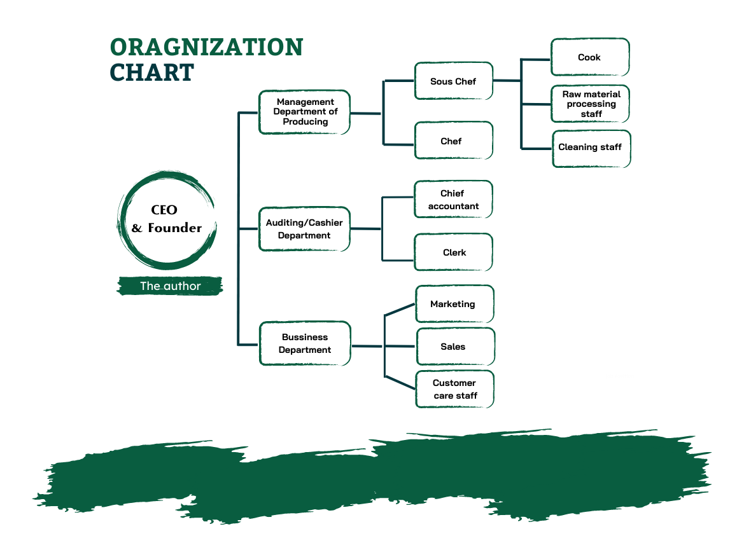

Chang Vegetarian Restaurant is a start-up business with a small investment, so basically initially the business plan will only have 3 main parts including the production management department, the audit department, and finally the business department. The CEO will also be directly involved in departmental management to ensure accuracy, satisfaction, and transparency.

**SLOGAN in HRM**

***"PASSION DRIVES PROGRESS: TOGETHER WE THRIVE”***

The production management department plays the most important and invested role in the three main departments. This department will plan and manage production activities such as coordination, direction, and organization, and flexibly and directly supervise all activities of employees and equipment in the factory. These take place for ensuring the timely production of goods on order and meeting quantity, quality, and cost requirements. The production management department must also be flexible, continuously researching and developing products to adapt to market changes to create highly innovative and competitive products. At the same time, comply with regulations on occupational safety, protect the health of employees, and ensure ethical standards in business.

As a vegetarian food manufacturing and trading business with a constantly updated revenue and expense frequency, the audit department plays an important role in the cash flow of Chang Vegetarian Restaurant. The audit department will help businesses manage revenues and expenditures from production and business activities, employee salaries, and prepare financial statements for superiors. Specifically, employees are also responsible for maintaining and operating cash registers, point of sale (POS) systems, or any other electronic payment system. At the same time, they are also the restaurant representatives who interact directly with customers such as greeting customers, answering questions, and resolving any problems or differences related to payment. From there, the CEO can make better decisions, forecasts, and budget management.

The sales department ensures that the company's products and services are effectively and profitably promoted, introduced, and marketed. This department will perform tasks such as business planning including defining goals, strategies, budgets, methods, and channels to reach customers. Staff will collect and analyze information about the market, competitors, potential customers, and consumption trends and understand the needs and wants of customers about products to design, appropriate advertising, marketing, and business strategies in the future. At the same time, they will also find and maintain relationships with business partners, assisting the CEO to negotiate and sign contracts.

# Conclusion & Reflection:

Chang Vegetarian Restaurant's plant-based meat project is a transformative journey of innovation and discovery for animal welfare, domestic and foreign meat markets and global climate change. The results of our project demonstrate the feasibility and potential impact of plant-based meat on many fronts based on the market data and surveys provided above. The author's plant-based meat production project has significantly reduced greenhouse gas emissions, land use, and water consumption compared to traditional animal agriculture. Furthermore, the author's research and development efforts have led to the creation of plant-based meat products that compete with the sensory experience of traditional meat. Through continuous improvement and feedback from consumers, we have managed to enhance the taste, texture, and nutritional composition of these products, making them appealing to a wider audience, including those who may have previously been hesitant to adopt a plant-based diet.

Throughout the project, various obstacles and setbacks have tested the author's determination. Technical barriers to achieving the perfect texture and taste, supply chain constraints, and some consumers' misconceptions about plant-based products are some of the challenges the author faced. However, that has improved as the product testing process has become embraced by many consumers. The satisfaction and enthusiasm of individuals who were previously sceptical of plant-based alternatives confirm the potential of our project to create real change in the food industry. The success of plant-based meat depends on continuous research and development, as well as strategic partnerships with food industry stakeholders. The author aims to scale up production, increase accessibility, and continue to refine nutritional and flavour profiles to reach even more audiences.

In short, the plant-based meat production project was a remarkable experience that linked the author's passion for sustainability and ethical practices with a tangible solution to the global food system. By creating a viable alternative to conventional meat, the author believes that this project can pave the way towards a more compassionate, sustainable, and healthier future for generations to come. As it moves forward, Chang Vegetarian Restaurant remains committed to pushing the boundaries of innovation and driving a positive impact on our planet and its residents through responsible food choices.

# References

|  |
| --- |
|  |

Abbass, K., Qasim, M.Z., Song, H., Murshed, M., Mahmood, H. and Younis, I., 2022. A review of the global climate change impacts, adaptation, and sustainable mitigation measures. *Environmental Science and Pollution Research, 29*(28), pp.42539-42559.

Andreani, G., 2022. Using consumer science to improve healthy and sustainable eating behavior. *ASTI.*

Anh, N. (2021) *Thịt bò giả giá 1,5 triệu đồng/kg, Người Lao Động*. Available at: https://nld.com.vn/kinh-te/thit-bo-gia-gia-15-trieu-dong-kg-20210326214736754.htm (Accessed: 19 June 2023).

Au Lac (no date) *About Us - thực Phẩm Chay*. Available at: https://aulac-vegan.com/en/about-us/ (Accessed: 12 June 2023).

Bao Han (2021) *Shark tank việt nam: Shark Louis Bắt tay shark Liên Rót Vốn Vào startup ‘thịt thực vật’, BAO DIEN TU VTV*. Available at: https://vtv.vn/truyen-hinh/shark-tank-viet-nam-shark-louis-bat-tay-shark-lien-rot-von-vao-startup-thit-thuc-vat-20210614131203403.htm (Accessed: 09 June 2023).

Clarissia, S.M.S., 2020. A study on Ansoff Matrix Technique: As a growth strategy and an adaptive learning technique adopted in the leading brand of products. *BIMS Journal of Management*, p.18.

Cherry, E., 2015. I was a teenage vegan: motivation and maintenance of lifestyle movements. *Sociological inquiry*, *85*(1), pp.55-74.

Duy, Đ.N.N., 2022. Tại Sao Các Chuỗi Cung Ứng Thức Ăn Nhanh Lại Không Thành Công Ở Việt Nam.

Fingas, J. (2020) *Beyond Meat says its new plant-based burgers are juicier and healthier, Engadget.* Available at: https://www.engadget.com/beyond-meat-burger-2021-151233179.html (Accessed: 09 June 2023).

Ghosh et al., 2020. Agriculture, dairy and fishery farming practices and greenhouse gas emission footprint: a strategic appraisal for mitigation. *Environmental Science and Pollution Research, 27,* pp.10160-10184.

Goyal et al., 2020. Vegetarians, vegans and the carbon footprint: An increased environmental consciousness among the youths*. Indian Journal of Health & Wellbeing*, 11.

GSO Vietnam (2023) *Thông Cáo Báo Chí Kết quả Khảo Sát mức Sống Dân cư 2022, General Statistics Office of Vietnam.* Available at: https://www.gso.gov.vn/su-kien/2023/05/thong-cao-bao-chi-ket-qua-khao-sat-muc-song-dan-cu-2022/ (Accessed: 04 June 2023).

GSO Vietnam (2023) *Thông Cáo Báo Chí Kết quả Khảo Sát mức Sống Dân cư 2022, General Statistics Office of Vietnam.* Available at: https://www.gso.gov.vn/su-kien/2023/05/thong-cao-bao-chi-ket-qua-khao-sat-muc-song-dan-cu-2022/#:~:text=2.1.&text=Thu%20nh%E1%BA%ADp%20t%C4%83ng%20%C4%91%E1%BB%81u%20%E1%BB%9F,%25%20so%20v%E1%BB%9Bi%20n%C4%83m%202021). (Accessed: 08 June 2023).

GSO Vietnam (2023) *Thông Cáo Báo Chí Tình Hình Kinh TẾ - xã Hội Quý I NĂM 2023, General Statistics Office of Vietnam.* Available at: https://www.gso.gov.vn/tin-tuc-thong-ke/2023/03/thong-cao-bao-chi-tinh-hinh-kinh-te-xa-hoi-quy-i-nam-2023/ (Accessed: 04 June 2023).

GSO Vietnam(2021) *Triển vọng tươi Sáng Của Ngành công Nghiệp Sản xuất, Chế Biến thực phẩm, General Statistics Office of Vietnam.* Available at: https://www.gso.gov.vn/du-lieu-va-so-lieu-thong-ke/2021/05/trien-vong-tuoi-sang-cua-nganh-cong-nghiep-san-xuat-che-bien-thuc-pham/ (Accessed: 02 July 2023).

Hall, M. (2023) *Porter’s 5 forces vs. Pestle Analysis: What’s the difference?, Investopedia*. Available at: https://www.investopedia.com/ask/answers/041015/whats-difference-between-porters-5-forces-and-pestle-analysis.asp (Accessed: 30 May 2023).

Harris et al., 2022. Tensions and coalitions: A new trade agreement affects the policy space for nutrition in Vietnam*. Food Security, 14*(5), pp.1123-1141.

Hoang, L.P. (2022) *Việt Nam - thị trường tiềm năng của thực phẩm thuần chay, Thời báo Kinh tế toàn cầu với 5 ngôn ngữ.* Available at: https://vietnam.ajunews.com/view/20220810133110089 (Accessed: 12 June 2023).

Jan, S.U., Shah, K. and Mand, N., 2023. Point of Sale System*. Available at SSRN 4368998.*

Jang, H.W. and Lee, S.B., 2020. Serving robots: Management and applications for restaurant business sustainability. *Sustainability, 12*(10), p.3998.

Kenton, W. (2023) *SWOT analysis: How to with table and example, Investopedia.* Available at: https://www.investopedia.com/terms/s/swot.asp (Accessed: 30 May 2023).

KHAN et al., 2022. CONCERNS REGARDING FOOD SAFETY AND FUTURE RESEARCH APPROACHES IN THE CASE OF WHEAT IN THE CONTEXT OF URBANIZATION IN BANGLADESHI DIET*. Journal of Advances in Food Science & Technology, 9*(1), pp.1-11.

Li et al., 2022, April. The Environmental Impact of Plastic Grocery Bags and Their Alternatives. In *IOP Conference Series: Earth and Environmental Science* (Vol. 1011, No. 1, p. 012050). IOP Publishing.

Lie, D., Inrawan, A., Silitonga, H.P. and Sudirman, A., 2022. Adoption of social media marketing: Contribution of knowledge management and market orientation to competitive advantages. In *Acceleration of Digital Innovation & Technology towards Society 5.0* (pp. 185-192).

Long, H.C. and Nhut, N.M., 2022. Ảnh hưởng thương hiệu người nổi tiếng trực tuyến lên động lực tham gia của khách hàng: Hành vi tương tác ảo và dự định mua hàng. *Tạp chí Nghiên cứu Tài chính-Marketing*, pp.52-62.

Martinelli, E. and De Canio, F., 2022. Non-vegan consumers buying vegan food: the moderating role of conformity*. British Food Journal, 124*(1), pp.14-30.

Martín-Rios, C. and Ciobanu, T., 2019. Hospitality innovation strategies: An analysis of success factors and challenges*. Tourism Management, 70*, pp.218-229.

Martin-Rios, C., Demen-Meier, C., Gössling, S. and Cornuz, C., 2018. Food waste management innovations in the foodservice industry. *Waste management, 79*, pp.196-206.

Mordor Intelligence (2023) *Vegan cosmetics market size & share analysis - industry research report - growth trends, Vegan Cosmetics Market Size & Share Analysis - Industry Research Report - Growth Trends.* Available at: https://www.mordorintelligence.com/industry-reports/vegan-cosmetics-market (Accessed: 02 July 2023).

Niu, Z., Chen, C., Gao, Y., Wang, Y., Chen, Y. and Zhao, K., 2022. Peer effects, attention allocation and farmers' adoption of cleaner production technology: Taking green control techniques as an example. *Journal of Cleaner Production, 339*, p.130700.

Nolden, A.A. and Forde, C.G., 2023. The nutritional quality of plant-based foods. *Sustainability, 15*(4), p.3324.

Nguyen, N.T.K. (2018) *Luật trồng trọt 2018 SỐ 31/2018/QH14, THƯ VIỆN PHÁP LUẬT*. Available at: https://thuvienphapluat.vn/van-ban/Linh-vuc-khac/Luat-Trong-trot-2018-336355.aspx (Accessed: 08 June 2023).

PV (2023) *Xu Hướng ăn Uống Lành Mạnh: Sản Phẩm TỰ nhiên và không đường Lên Ngôi, Báo Sức khỏe & Đời sống - Cơ quan ngôn luận của Bộ Y tế.* Available at: https://suckhoedoisong.vn/xu-huong-an-uong-lanh-manh-san-pham-tu-nhien-va-khong-duong-len-ngoi-169230615075715248.htm (Accessed: 16 June 2023).

Pham, H.T. and Duong, T.C. (2022) *Tổng hợp 25 văn bản quy Phạm Pháp Luật Lĩnh vực an toàn thực phẩm, Thu Vien Phap Luat.* Available at: https://thuvienphapluat.vn/chinh-sach-phap-luat-moi/vn/thoi-su-phap-luat/tu-van-phap-luat/45122/tong-hop-van-ban-quy-pham-phap-luat-linh-vuc-an-toan-thuc-pham (Accessed: 08 June 2023).

Rasouli, N., Rasoolimanesh, S.M., Rahmani, A.K., Momayez, A. and Torabi, M.A., 2022. Effects of customer forgiveness on brand betrayal and brand hate in restaurant service failures: does apology letter matter? *Journal of Hospitality Marketing & Management, 31*(6), pp.662-687.

Schönfeldt, H., 2020. *Beyond meat: the future of food* (Doctoral dissertation).

Skowronski, K., Benton Jr, W.C. and Handley, S., 2022. The moderating influence of supplier culture on the relationship between buyer power and supplier shirking. *Journal of Operations Management, 68*(3), pp.270-301.

Sridhar, K., Bouhallab, S., Croguennec, T., Renard, D. and Lechevalier, V., 2022. Recent trends in design of healthier plant-based alternatives: nutritional profile, gastrointestinal digestion, and consumer perception. *Critical Reviews in Food Science and Nutrition*, pp.1-16.

Statista (2023) *Meat substitutes - china: Statista market forecast, Statista*. Available at: https://www.statista.com/outlook/cmo/food/meat/meat-substitutes/china (Accessed: 17 June 2023).

Statista (2023) *Meat substitutes - europe: Statista market forecast, Statista.* Available at: https://www.statista.com/outlook/cmo/food/meat/meat-substitutes/europe (Accessed: 17 June 2023).

Statista (2023) *Meat substitutes - indonesia: Statista market forecast, Statista*. Available at: https://www.statista.com/outlook/cmo/food/meat/meat-substitutes/indonesia (Accessed: 17 June 2023).

Statista (2023) *Meat substitutes - japan: Statista market forecast, Statista.* Available at: https://www.statista.com/outlook/cmo/food/meat/meat-substitutes/japan (Accessed: 17 June 2023).

Statista (2023) *Meat substitutes – south korea: Statista market forecast, Statista*. Available at: https://www.statista.com/outlook/cmo/food/meat/meat-substitutes/south-korea (Accessed: 17 June 2023).

Statista (2023) *Meat substitutes - vietnam: Statista market forecast, Statista*. Available at: https://www.statista.com/outlook/cmo/food/meat/meat-substitutes/vietnam (Accessed: 17 June 2023).

Szenderák, J., Fróna, D. and Rákos, M., 2022. Consumer acceptance of plant-based meat substitutes: a narrative review. *Foods, 11*(9), p.1274.

Tan, C.Y., Song, M., Hong, K.J., Lin, J., Yap, K. and Natsume, T., 2020. Food Tech: Alternative Protein Opportunities in Asia.

Tu, U. (2022) *Năm 2022, mỗi Người Việt Tiêu Thụ 23,5 kg thịt Heo, Báo Pháp Luật TP. Hồ Chí Minh*. Available at: https://plo.vn/nam-2022-moi-nguoi-viet-tieu-thu-235-kg-thit-heo-post684070.html (Accessed: 20 June 2023).

Tyndall, S.M., Maloney, G.R., Cole, M.B., Hazell, N.G. and Augustin, M.A., 2022. Critical food and nutrition science challenges for plant-based meat alternative products. *Critical Reviews in Food Science and Nutrition*, pp.1-16.

Thu, B.T. and Trang, N.T.Q., 2019. NGHIÊN CỨU CÁC NHÂN TỐ TÁC ĐỘNG ĐẾN GIÁ TRỊ KHÁCH HÀNG CẢM NHẬN CỦA CÁC NHÀ BÁN LẺ TRỰC TUYẾN NHỎ TRÊN FACEBOOK TRÊN ĐỊA BÀN HÀ NỘI.

Tráng, T.B.T., Hằng, T.H.T., Ninh, T.Đ.T.H. and Hồng, T.D.N., 2021. Kinh doanh thương mại trên nền tảng số của doanh nghiệp bán lẻ Việt Nam trước và trong dịch COVID-19. In Kinh tế Việt Nam trên con đường chuyển đổi số. Trường Đại học Kinh tế Tp. Hồ Chí Minh.

TRỌNG, M., HÀNH, T., CHAY, V. and NAM, T.V., 2021. SOME KEY FACTORS IMPACTING CUSTOMER’S PURCHASE INTENTION VEGETARIAN FOOD IN VIETNAM.

Van et al., 2019. Basic issues about organization and apparatus of the current political system in Vietnam. *International Journal of Advance Research, Ideas and Innovations in Technology, 5*(6), pp.160-167.

Van, H. (2021) *Vissan Thu 13 tỷ đồng Mỗi Ngày TỪ cung ứng thịt Heo, BAO MOI.* Available at: https://baomoi.com/vissan-thu-13-ty-dong-moi-ngay-tu-cung-ung-thit-heo/c/39681903.epi (Accessed: 02 July 2023).

VFA (2023) *Cục an toàn thực phẩm - BỘ Y TẾ*, *Cục An toàn thực phẩm - Bộ Y Tế*. Available at: https://vfa.gov.vn/ (Accessed: 14 August 2023).

Việt, N.Đ., 2022. Hiện trạng về tiền điện tử trên thế giới và đề xuất chính sách cho Việt Nam. In Research Contribution For All. Trường Đại học Kinh tế Tp. Hồ Chí Minh.

VPBank (2023) *Lãi suất Cho Vay Ngân Hàng Mới Nhất Hiện Nay [08/2023]*, *Khách hàng cá nhân*. Available at: https://www.vpbank.com.vn/bi-kip-va-chia-se/retail-story-and-tips/loans-category/lai-suat-vay-ngan-hang-moi-nhat-hien-nay-cap-nhat-12-2022 (Accessed: 13 August 2023).

Vuong, H.D. (2022) *Luật sở Hữu Trí Tuệ Sửa đổi 2022, THƯ VIỆN PHÁP LUẬT.* Available at: https://thuvienphapluat.vn/van-ban/So-huu-tri-tue/Luat-So-huu-tri-tue-sua-doi-2022-458435.aspx (Accessed: 08 June 2023).

Webber, J. (2021) *India’s first vegan meat company launches chicken and pork sausages to help the planet, Plant Based News.* Available at: https://plantbasednews.org/lifestyle/food/india-vegan-sausages/ (Accessed: 09 June 2023).

Wegwu, M.E., no date. Diversification Strategies and Business Performance in A Competitive Industry. *JournalNX, 6*(08), pp.190-199.

Weller, M., 2022. Vegetarian diets and cancer risk. *BMC Medicine, 20*(1), pp.1-2.

Win, F. (2021) *Việt Nam có thể trồng được Các Nguyên Liệu Chính Của thịt thực VẬT - MQ International: Flavors & Foods Ingredients, MQ International | Flavors & Foods Ingredients.* Available at: https://mqflavor.com/viet-nam-co-the-trong-duoc-cac-nguyen-lieu-chinh-cua-thit-thuc-vat/ (Accessed: 20 June 2023).

World Bank (2021) *GDP growth (annual %) in Vietnam, World Bank Open Data.* Available at: https://data.worldbank.org/indicator/NY.GDP.MKTP.KD.ZG?locations=VN (Accessed: 04 June 2023).

World Bank (2022) *Báo Cáo Mới Của Nhóm Ngân Hàng Thế Giới đề xuất LỘ trình để Việt Nam giải Quyết Các Rủi Ro Khí Hậu đồng Thời Duy Trì Tăng Trưởng kinh TẾ mạnh mẽ, World Bank.* Available at: https://www.worldbank.org/vi/news/press-release/2022/07/01/new-world-bank-group-report-proposes-path-for-vietnam-to-address-climate-risks-while-sustaining-robust-economic-growth (Accessed: 08 June 2023).

World Bank (2022) *Inflation, consumer prices (annual %) in Vietnam, World Bank Open Data.* Available at: https://data.worldbank.org/indicator/FP.CPI.TOTL.ZG?locations=VN (Accessed: 31 May 2023).

World Bank (2023) *Unemployment, total (% of total labor force) (modeled ILO estimate) - Vietnam, World Bank Open Data.* Available at: https://data.worldbank.org/indicator/SL.UEM.TOTL.ZS?locations=VN (Accessed: 06 June 2023).

Zhongming, Z., Linong, L., Xiaona, Y., Wangqiang, Z. and Wei, L., 2020. The business case for a UN treaty on plastic pollution WWF-Singapore.

# Appendix:

1. **SWOT Table:**

|  |  |
| --- | --- |
| SWOT | |
| Strengths | **Weaknesses** |
| S1: Diversified products to meet market needs.  S2: First-mover advantage.  S3: Applying technology and social networks to production and business.  S4: Product prices are reasonable for consumers.  S5: Quality and innovative service. | **W1:** Brand Recognition.  **W2:** Low partnerships network.  **W3:** Low production capacity.  **W4:** Competition in the industry is high.  **W5:** Consumer acceptance. |
| Opportunities | **Threats** |
| O1: The number of vegetarian restaurants increased.  O2: The number of vegetarians is increasing rapidly.  O3: The government promotes international trade.  O4: The power of social networks.  O5: Expansion to international market. | **T1:** High inflation rate.  **T2:** Use harmful plastic.  **T3:** Climate change affects production.  **T4:** Intellectual property challenges. |

1. **Product Survey Results:**

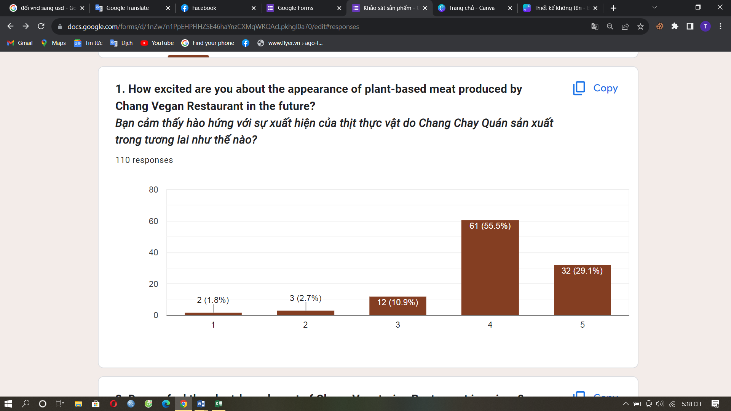

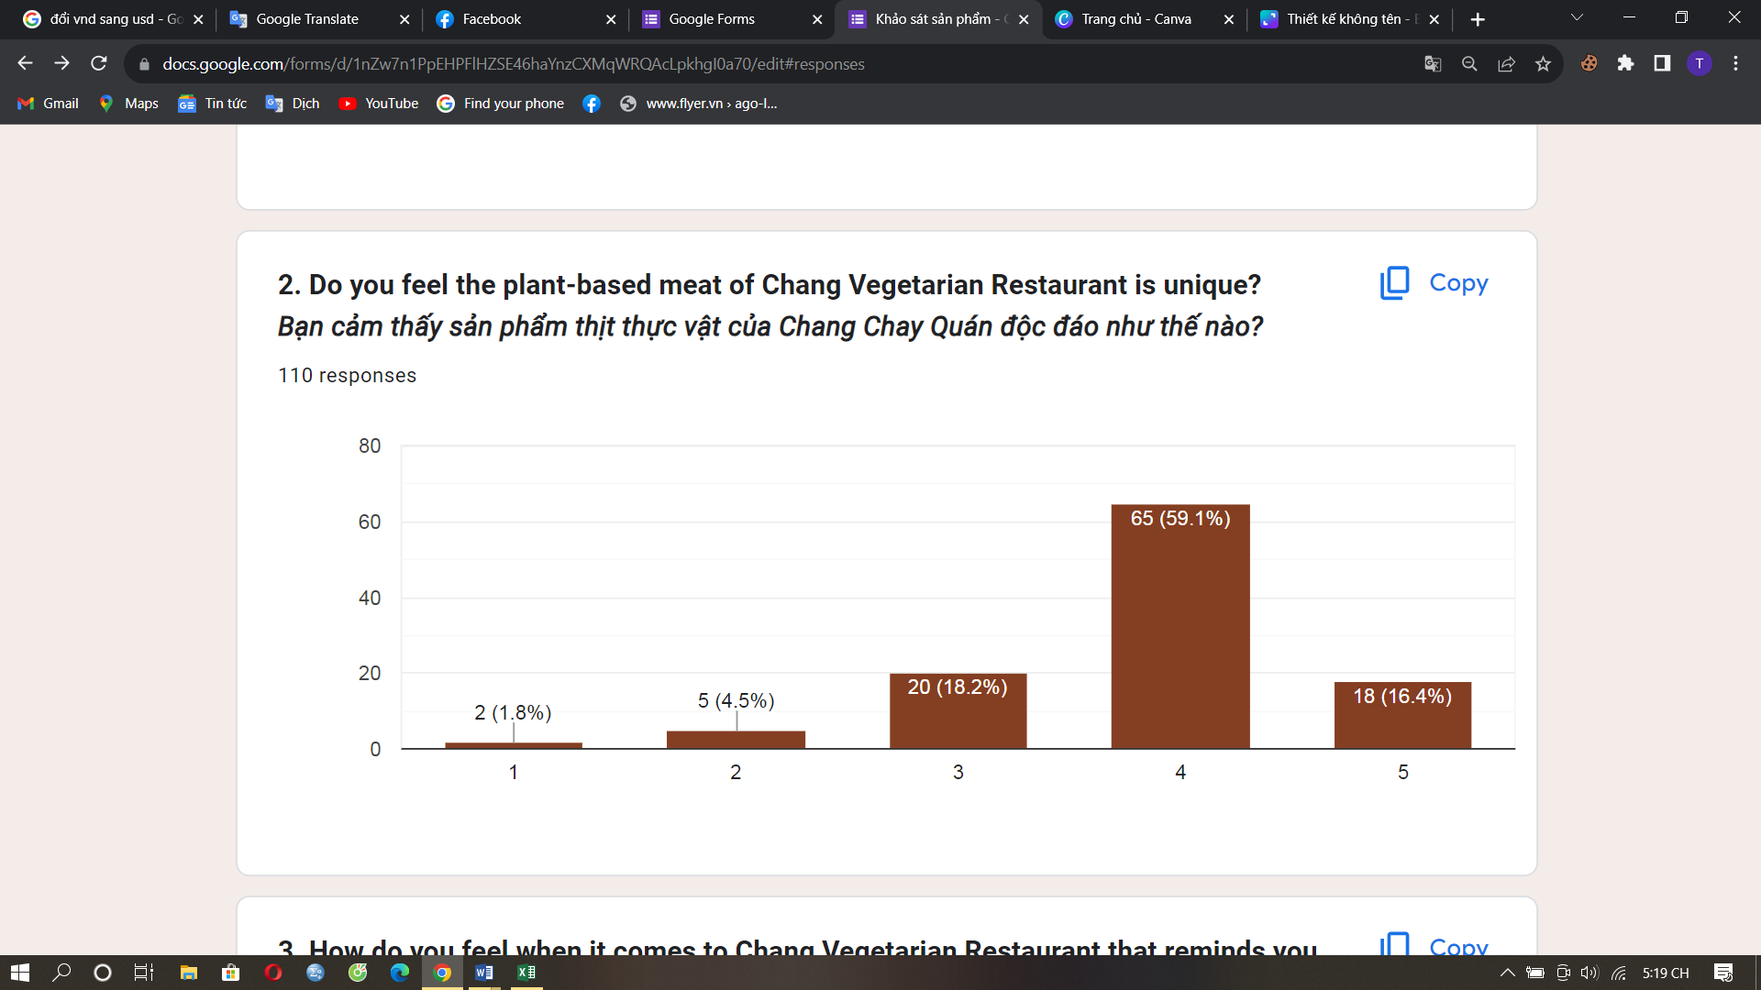

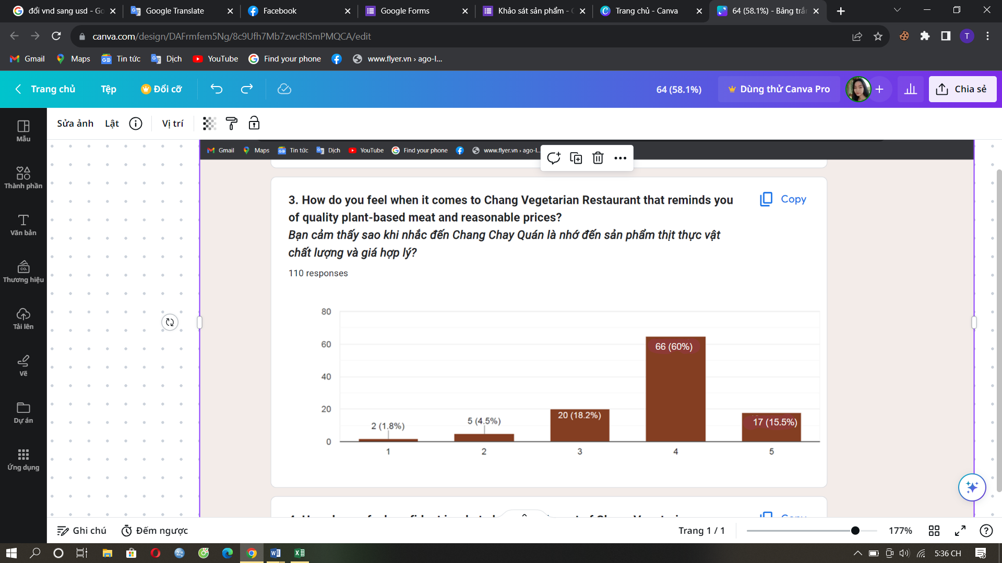

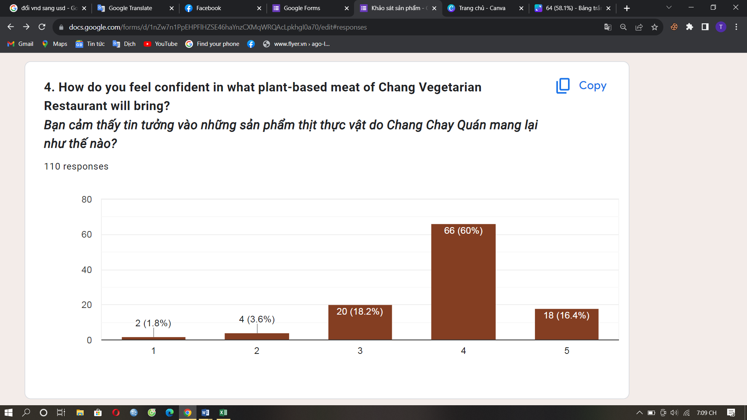

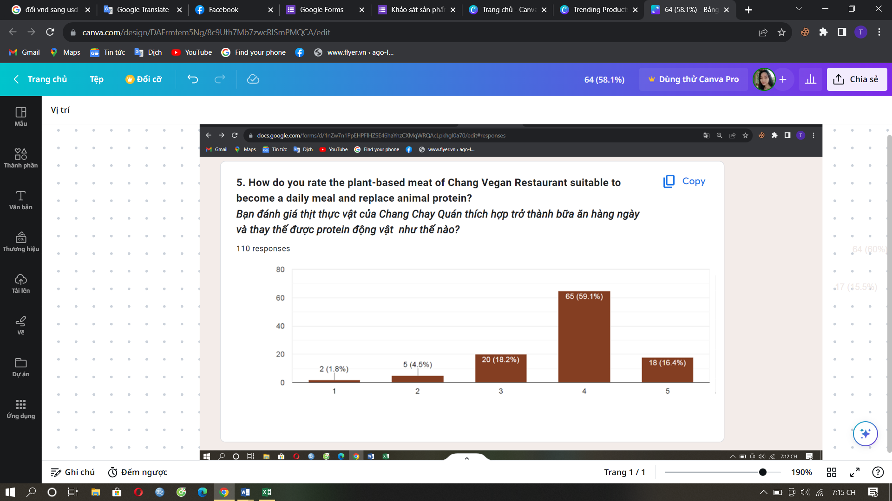

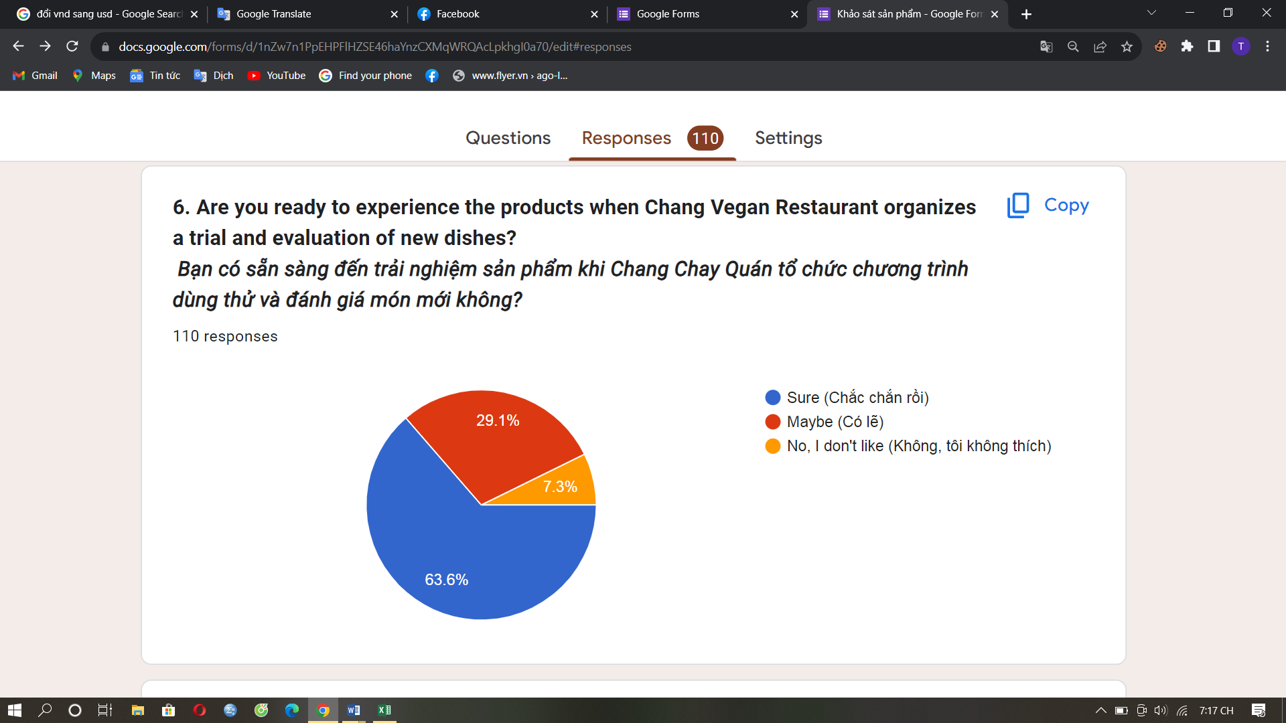

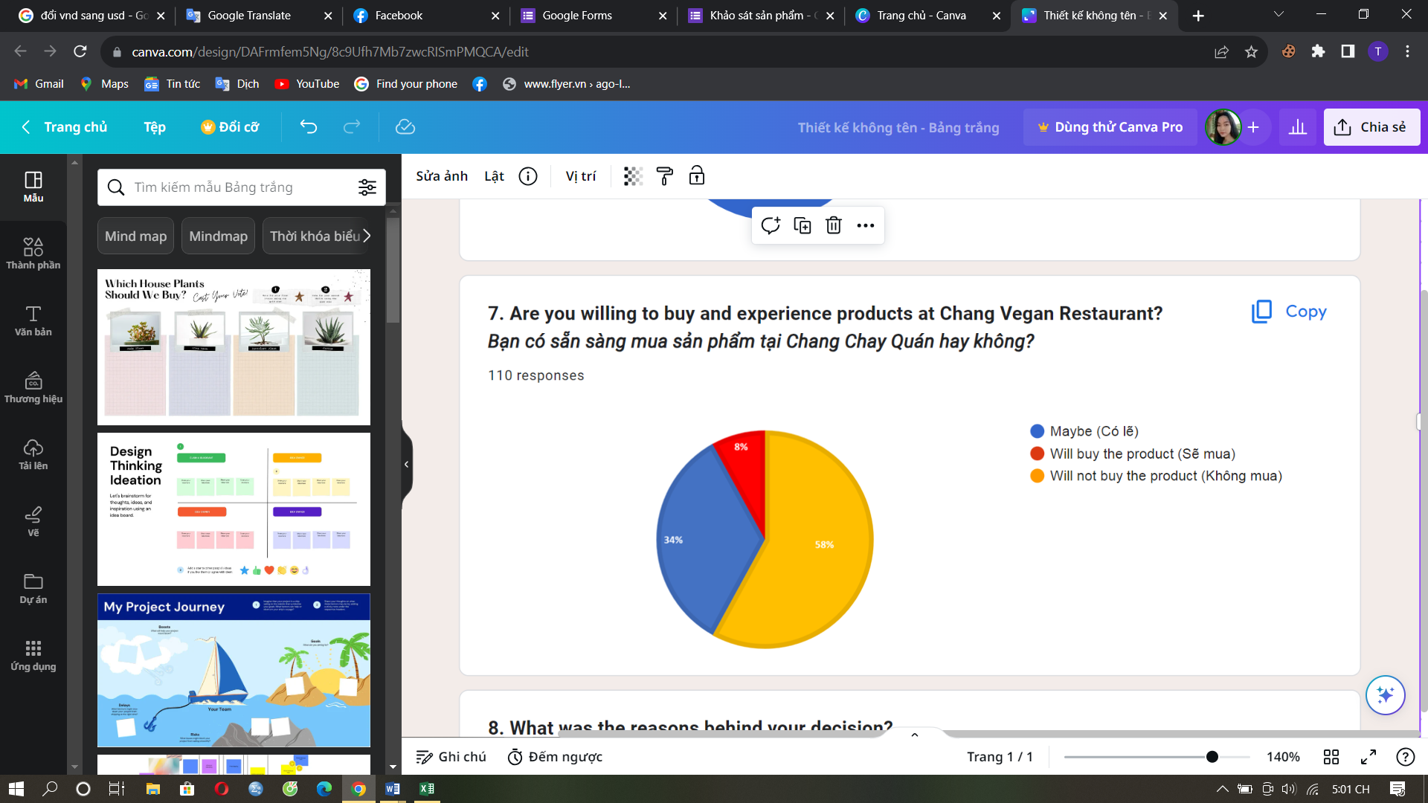

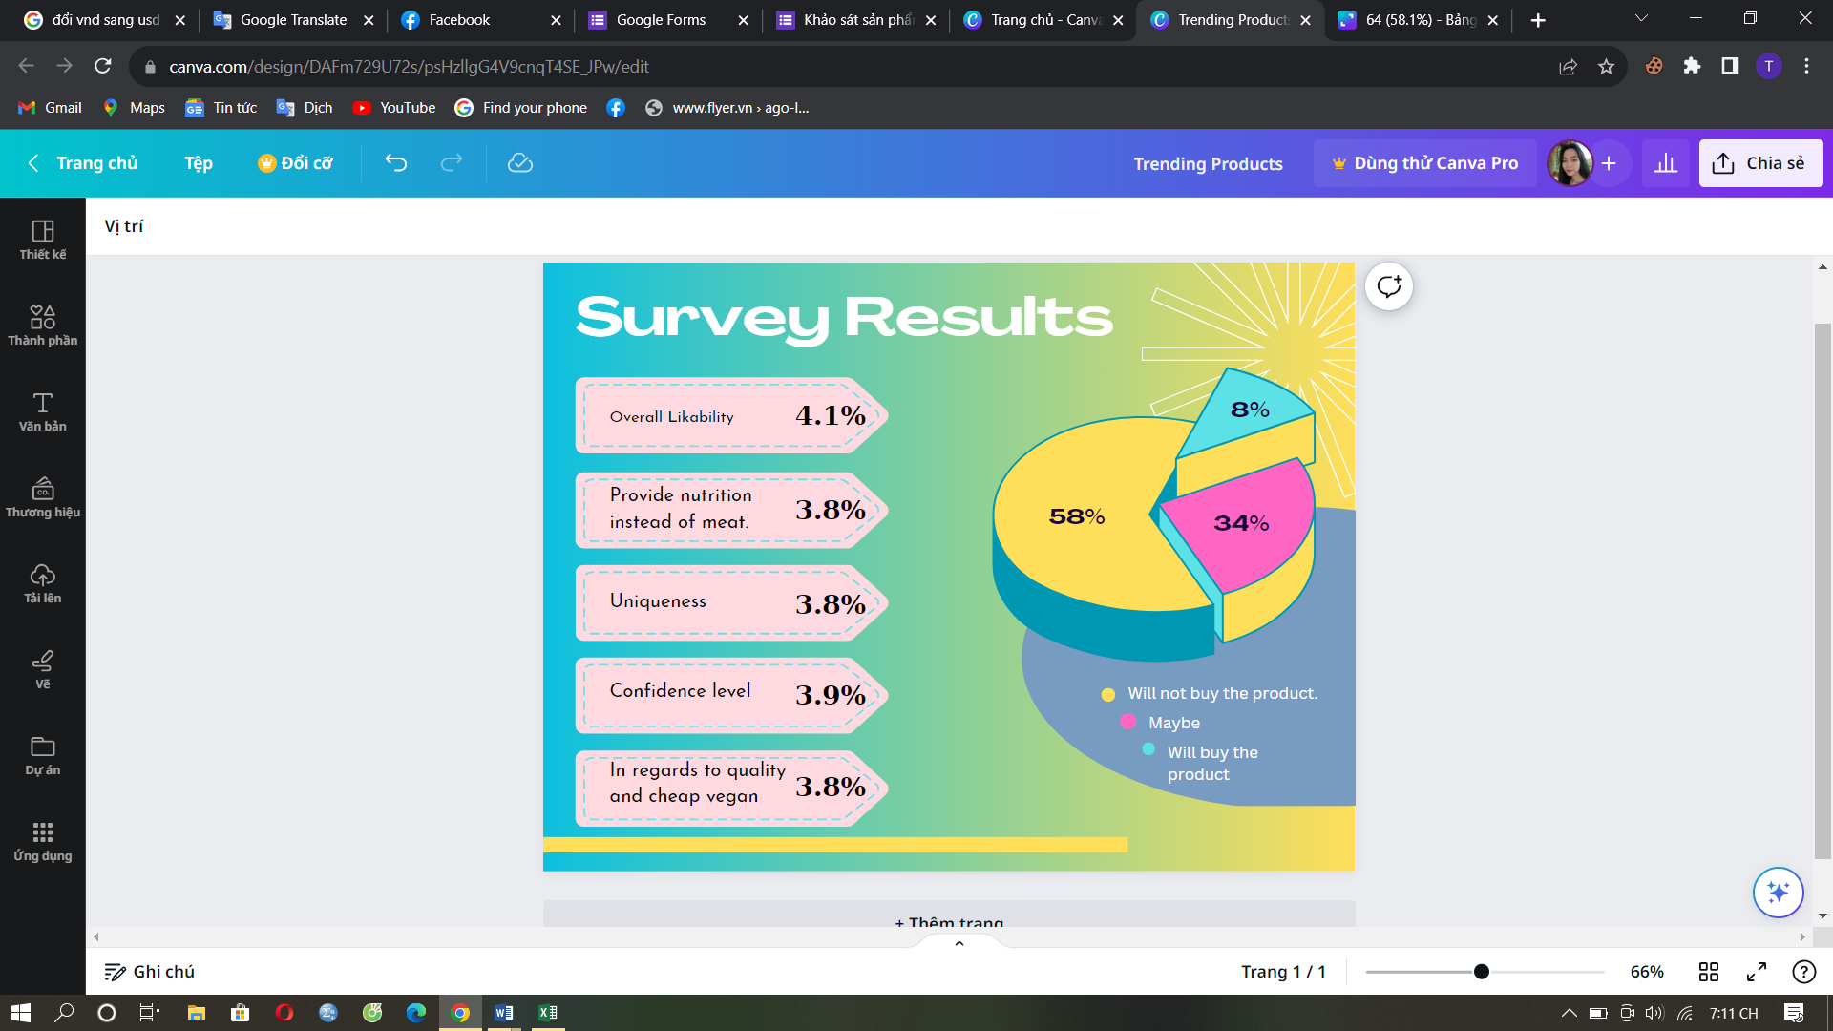

1. **Market survey questionnaire:**

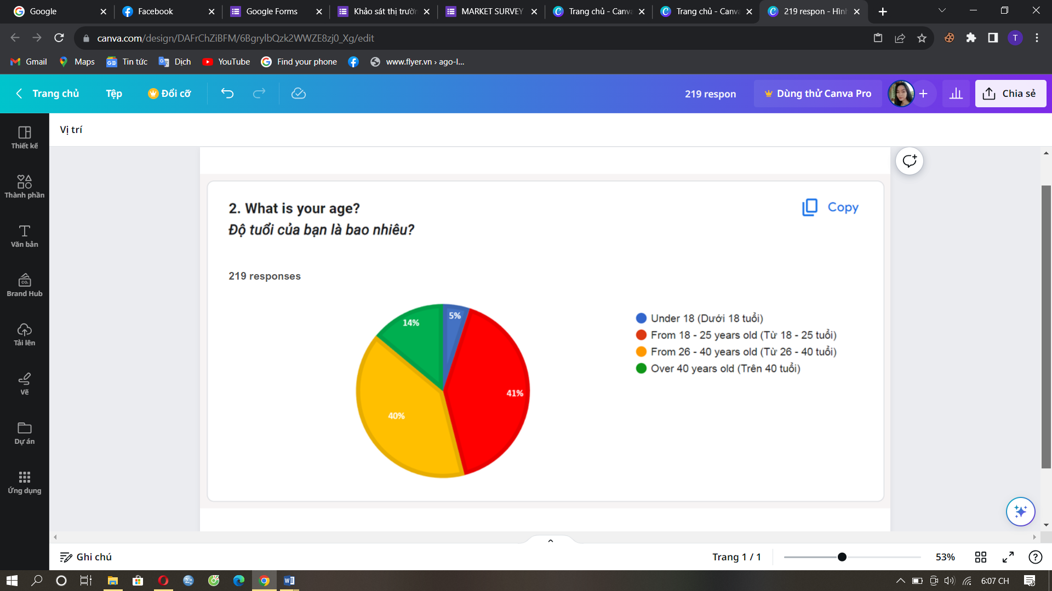

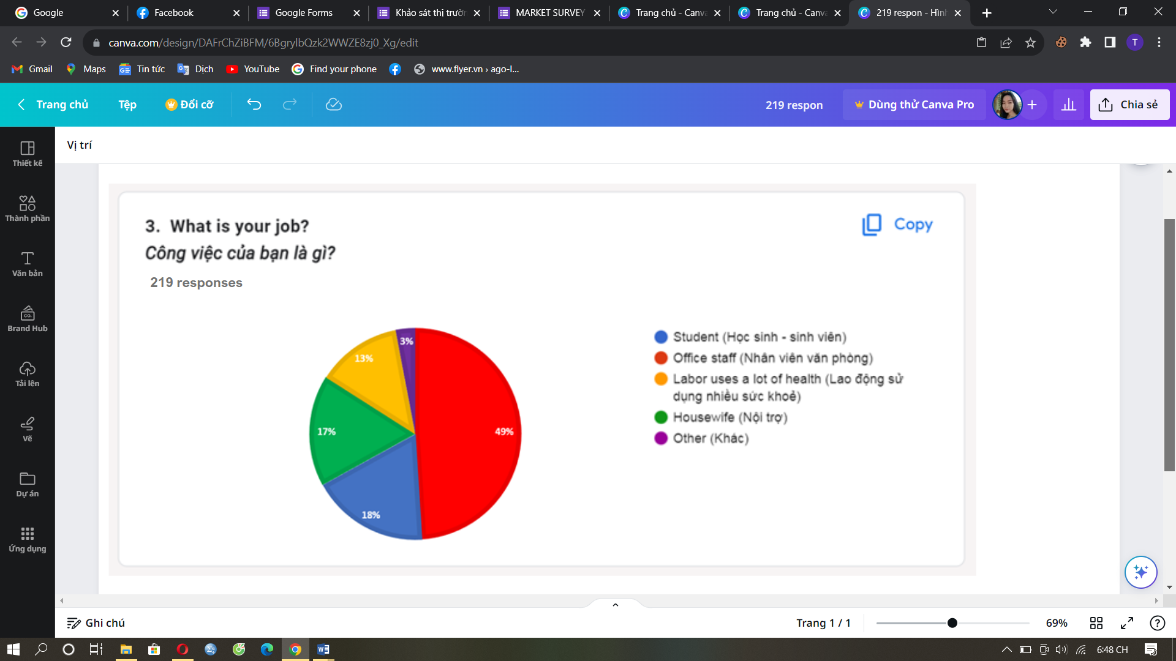

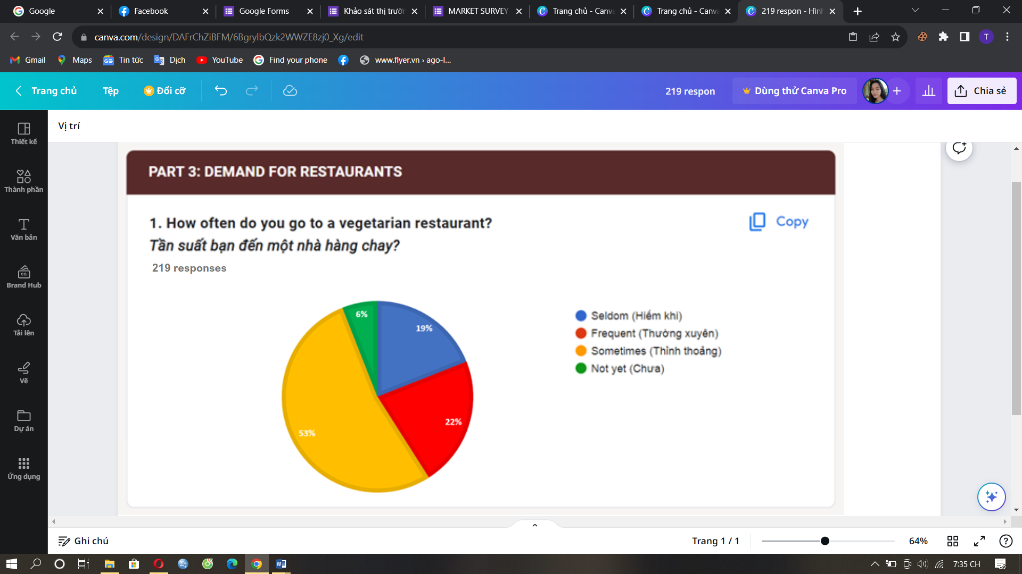

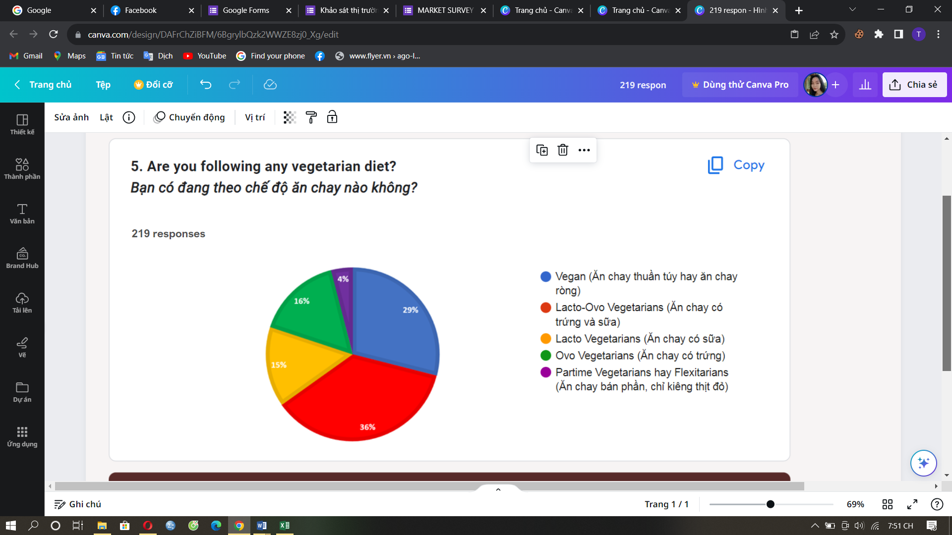

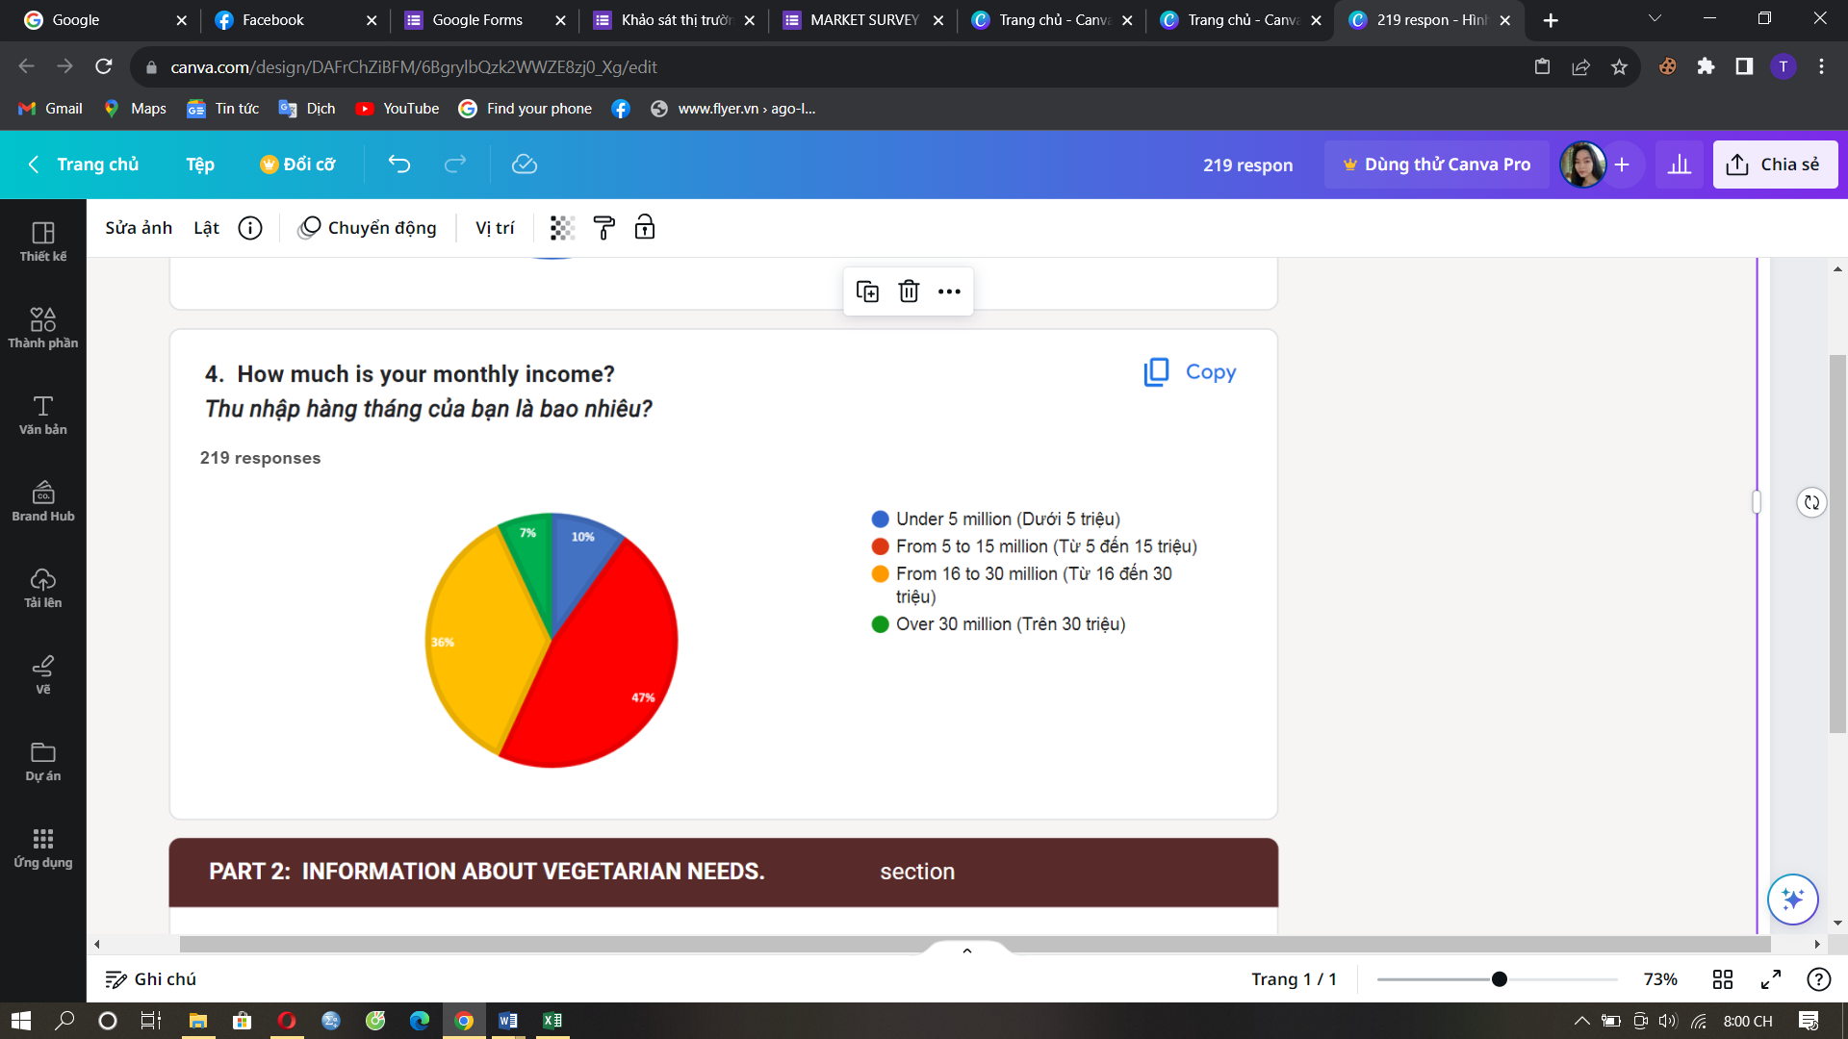

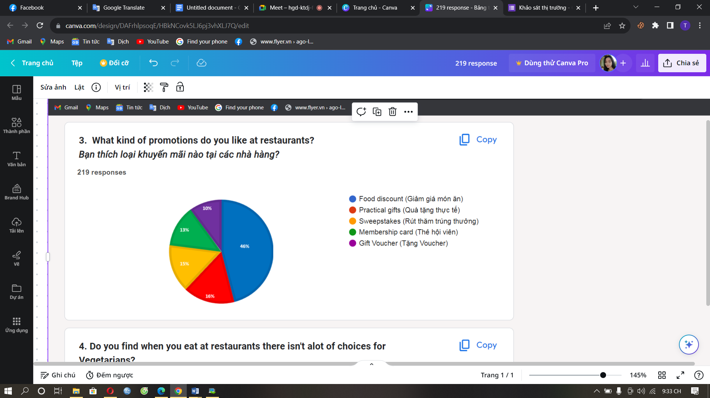

1. **Interview:**

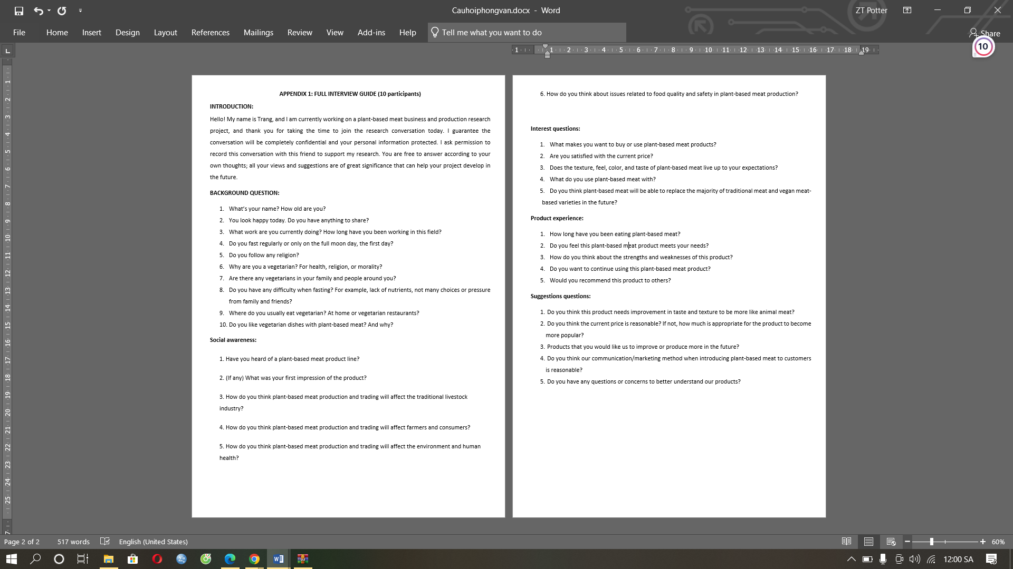

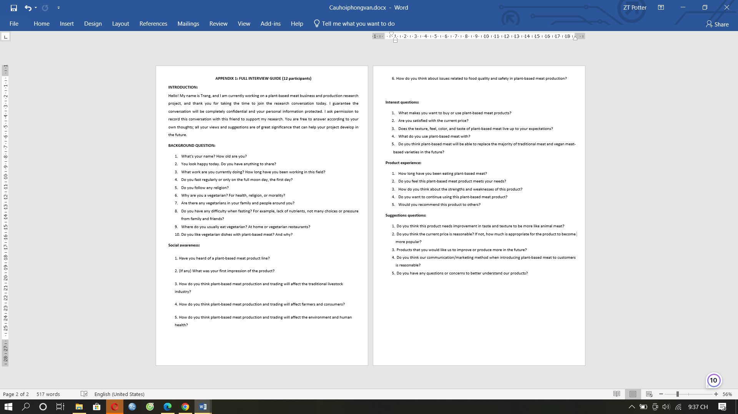

* 1. **Additional Survey Information:**

***Social awareness:***

The majority of survey respondents had heard of plant-based meat through advertisements and articles about it on the internet. They feel curious and skeptical how businesses can make plant-based meat and whether it tastes good. They wonder about the health and environmental benefits of plant-based meat versus animal-based meat. The majoity of interviewees agreed that the production and sale of plant-based meat would reduce demand for animal meat and reduce profits and market share of the livestock industry. On the other hand, it can also create new opportunities for innovation and cooperation between the two industries, such as the development of combined products or a co-branding strategy. The production and sale of plant-based meat will affect farmers through changes in their production systems and practices. Some farmers may benefit from growing more crops to produce plant-based meat, while others may face challenges from competing with plant-based meat producers cheaper and more efficient. Some consumers may also face barriers such as higher prices, limited quantities, or personal and cultural preferences that prevent them from using plant-based meat. The production and sale of plant-based meat will have a positive impact on the environment and human health.

***Product experience:***

The majority of participants had used plant-based meat from another brand because they wanted to reduce their environmental impact and improve their health. They found them easy to cook and prepare, and that it tasted a lot like animal meat but still met protein and iron needs with less fat and cholesterol than animal meat. The strength of this product is its environmental and health benefits, as well as its taste and texture. The weakness of this product is its higher price, lower availability, and lack of cultural acceptance in some regions. I also wish there were more plant-based flavors and meats to choose from. They also want to continue using this plant-based meat product and think it's a good alternative to animal meat.

1. **Price information of some products on the market:**

|  |  |  |
| --- | --- | --- |
|  | **Expected necessary equipment** | **Price** |
| 1 | Fryer without oil | 250 |
| 2 | Oven | 125 |
| 3 | Microwave oven | 125 |
| 4 | Kitchen infrared | 141 |
| 5 | Induction cooker | 133 |
| 6 | Dishes | 42 |
| 7 | Basic kitchen tools | 292 |
| 8 | Furniture | 1501 |
| 9 | Ice box | 21 |
| 10 | Order receiving device | 208 |
| 11 | Soy protein powder/kilogram | 4.59 |
| 12 | Flour/kilogram | 1.13 |